**ESCUELA NORMAL DE EDUCACIÓN PREESCOLAR**

**ENGLISH A1.2 DEVELOPING ELEMENTARY CONVERSATIONS**

**UNIT 3 FINAL PROJECT**

**Aim:** To give students practice with writing skills

Well, this is your opportunity to participate in the creation of a new sport for ENEP!!

Are you a sports fan??

* Give your new sport a name
* Describe the uniform
* How many members are there in the team?
* What can/can’t you do? Write 5 rules to play the game

This is Quidditch.

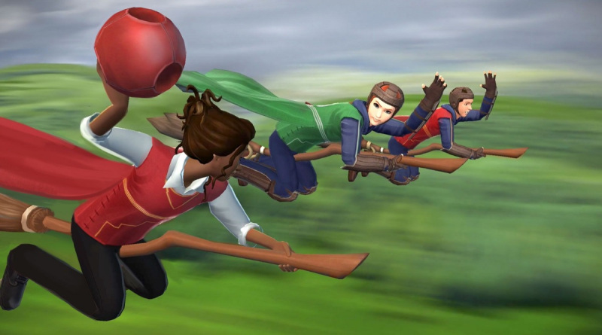Are you a student at Hogwarts? Well, only Hogwarts members can play this sport. Look at the uniforms!! They are super cool. Tight pants, a comfortable shirt, and colorful vests with a long cape. You need a broom to fly. You can’t fly without your special equipment!

The rules?

You can throw the ball, but you can’t kick the ball! You can fly low and you can fly high. The members of the team can be boys, or they can be girls.

My sport name:

writing check list

|  |  |
| --- | --- |
| **CONTENT** |  |
| Does my new game have a title? |  |
| Is there a description of the uniform ? |  |
| Does my new game include 5 rules? |  |
| **LANGUAGE** |  |
| Am I using complete sentences? Subject + verb+ complement |  |
| Am I using connectors but/and correctly? |  |
| Am I using a capital letter to begin a sentence or after a period? |  |
| Am I using commas correctly? |  |