ZOOM SESSION ACTIVITY

YOUR FAVORITE CITY

In your next session Friday 23rd you will prepare for your speaking activity.

You will use this worksheet (copy the chart onto your notebook)

1. Write information about your favorite city in the **You** column.

|  |  |  |
| --- | --- | --- |
|  | **You** | **Your partner** |
| Favorite city |  |  |
| Things you can do there |  |  |
| Things you should see there |  |  |
| Things you shouldn’t do there |  |  |

1. Interview a partner who chose a different city.

Write the answers in the **Your partner** column. Report to the class.

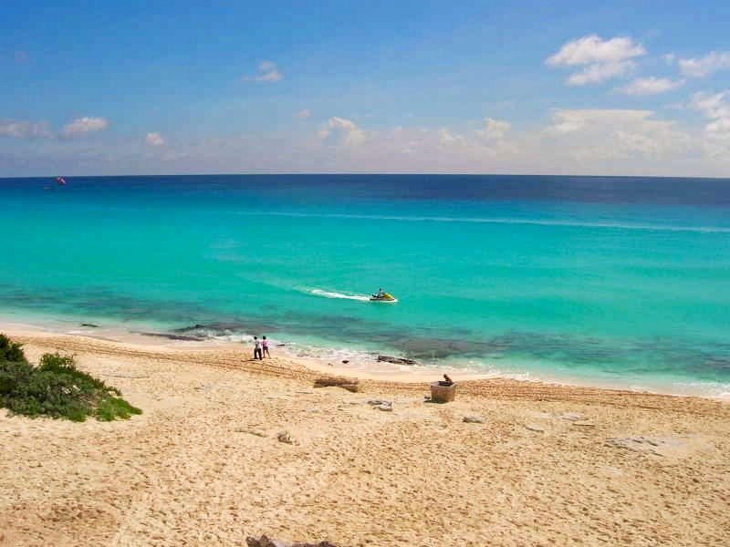

A: What’s your favorite city, Carla?

B: It’s Cancún

A: What **can** you **do** there?

B: You can go to the beaches.  
 They’re **really beautiful.**

A: What **should** people **see** there?

B: Well, they **shouldn’t miss** the  
 Mayan ruins at Tulum.