**ESCUELA NORMAL DE EDUCACIÓN PREESCOLAR**

**ENGLISH B1.2 BECOMING INDEPENDENT COMMUNICATORS**

**UNIT 2 – WORKING 9 TO 5**

**GRAMMAR**

1. **Read the discussions between students. Do you agree or disagree? Check the speaker you agree with the most.**

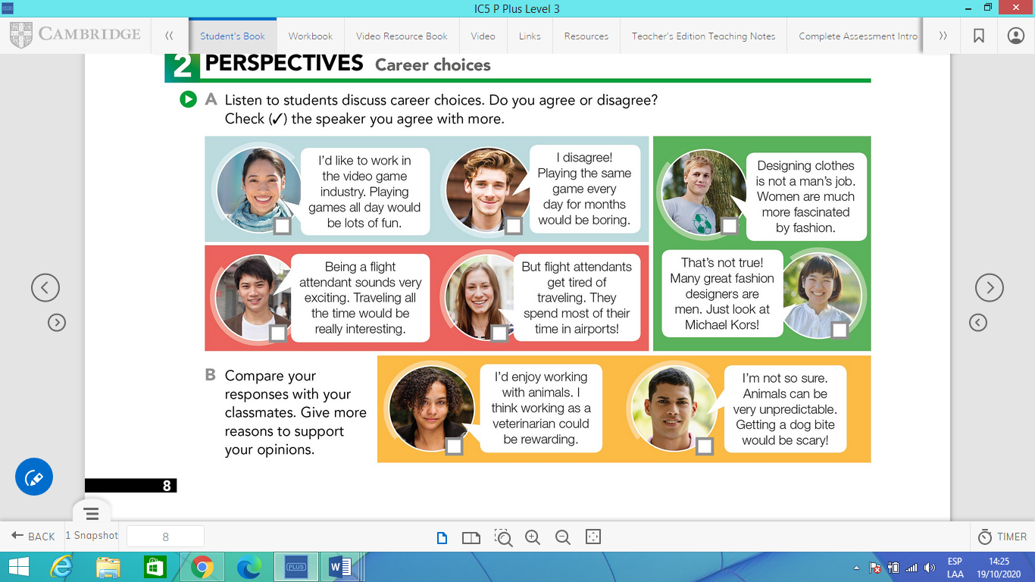





1. **Read the information carefully and watch the video.**

**GERUND: SUBJECT AND OBJECT**

***What is a gerund?***

Un gerundio es la forma base del verbo + -ing. Los gerundos pueden ser utilizados como sustantivos.

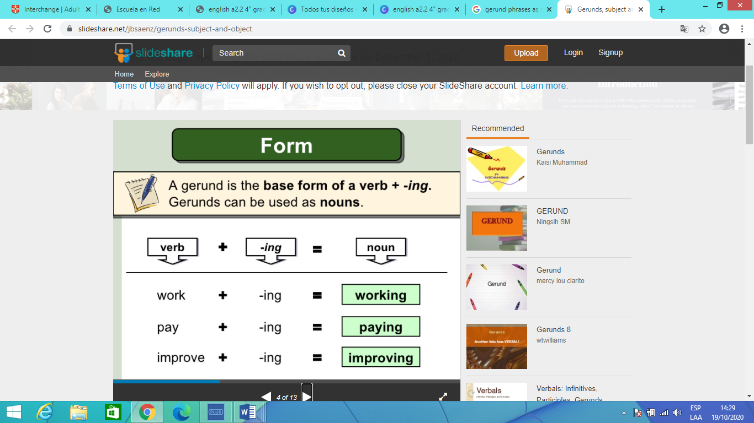

***Gerunds as subjects***

Un gerundio puede ser el sujeto de una oración. Siempre es singular. Se utiliza el verbo en tercera persona del singular después del gerundio.

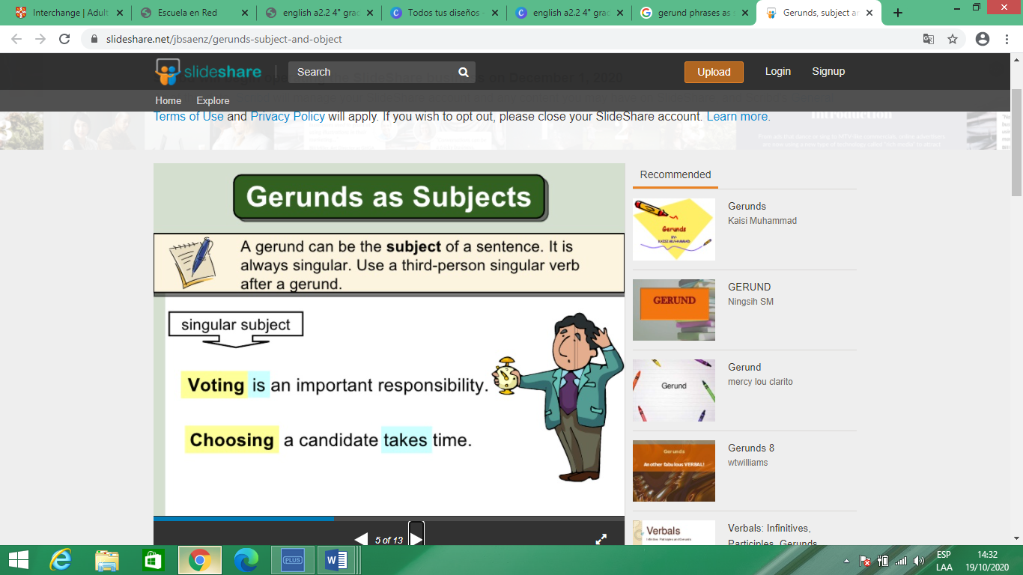

***Gerunds as objects***

Un gerundio puede ser también el objeto de ciertos verbos.

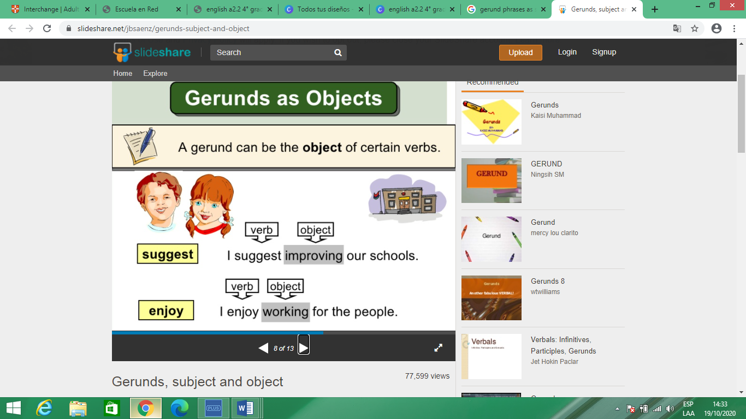

Go to <https://www.youtube.com/watch?v=t3uUiefUYqc> , watch the video “Using gerunds as subjects and objects of a sentence”, and analyze the following examples.

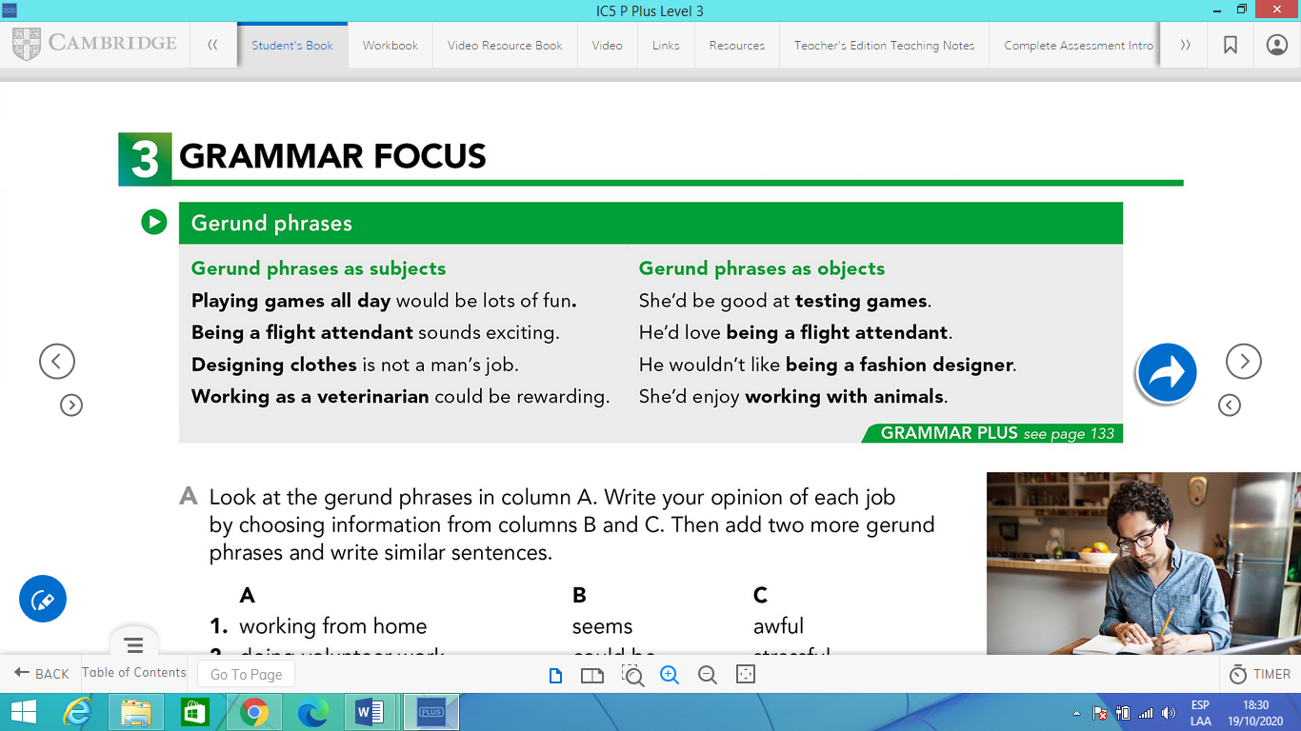

1. **GERUNDS AS SUBJECT. Look at the gerund phrases in column A. Write your opinion of each job by choosing information from columns B and C. Then add two more gerund phrases and write similar sentences. Check the example.**

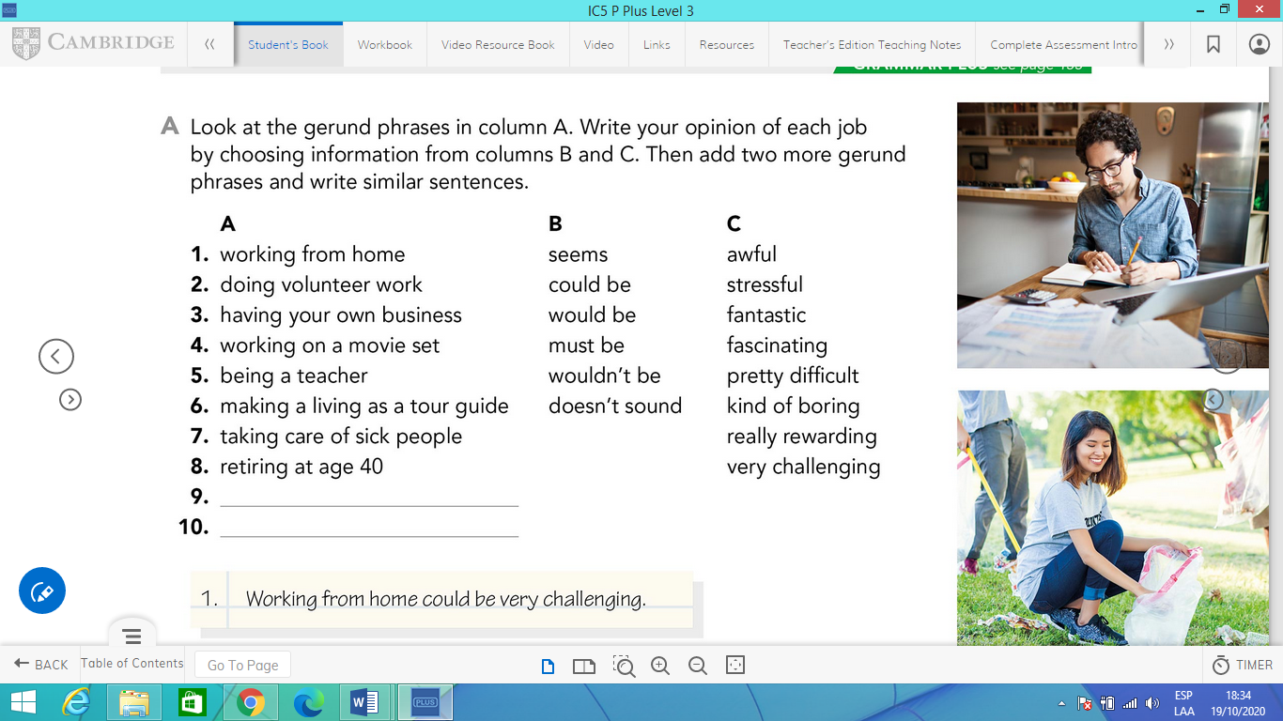

Write your sentences here.

1. *Working from home could be very challenging.*








11. **Give reasons for your opinions about five jobs in part A. Check the example.**

Ex. *In my opinion working from home could be very challenging because you have to learn to manage your time and it’s easy to get distracted.*

6. **GERUNDS AS OBJECT. Complete the sentences with gerund phrases. Check the example.**

Ex. *I’d get tired of doing the same thing everyday.*

1. I’d be interested in _____________________________________.

2. I’d be very excited about…

3. I’d enjoy…

4. I think I’d be good at…

5. I wouldn’t be very good at…

1. **Read the information carefully.**

**COMPARISONS**

Existen diversas formas en las que podemos hacer comparaciones, en este caso estaremos comparando trabajos o profesiones.

**Comparing with adjectives**

Para comparar utilizando adjetivos podemos utilizar adjective+er than / more or less + adjective than / as adjective as.

Examples:

*Being a doctor is* ***harder*** *than being a mechanic.*

*Working as a flight attendant is more* ***demanding*** *than working as a waiter.*

*Designing web pages isn’t as* ***interesting*** *as designing clothes.*

**Comparing with past participles**

El pasado participio de algunos verbos puede ser usado de la misma forma que los adjetivos (more-less + past participle / better-worse + past participle).

Examples:

*Being a destist is better* ***paid*** *than being a mechanic.*

*A waiter isn’t as* ***educated*** *as a teacher.*

**Comparing with nouns**

Otra forma de comparar es utilizando sustantivos (cosas, ideas, personas, animales). Diciendo que uno tiene más o menos de algo que el otro.

Examples:

*A doctor needs more* ***education*** *than a mechanic.*

*A teacher has better* ***hours*** *than a doctor.*

**Comparing with verbs**

También podemos utilizar verbos para comparar dos trabajos. Quién hace más o menos que el otro.

Examples:

*A dentist* ***works*** *as much as a mechanic.*

*A mechanic doesn’t* ***earn*** *as much as a dentist.*

Go to <https://www.youtube.com/watch?v=HK82SGjdpso> , watch the video “Making comparisons lesson”, and analyze the following examples.

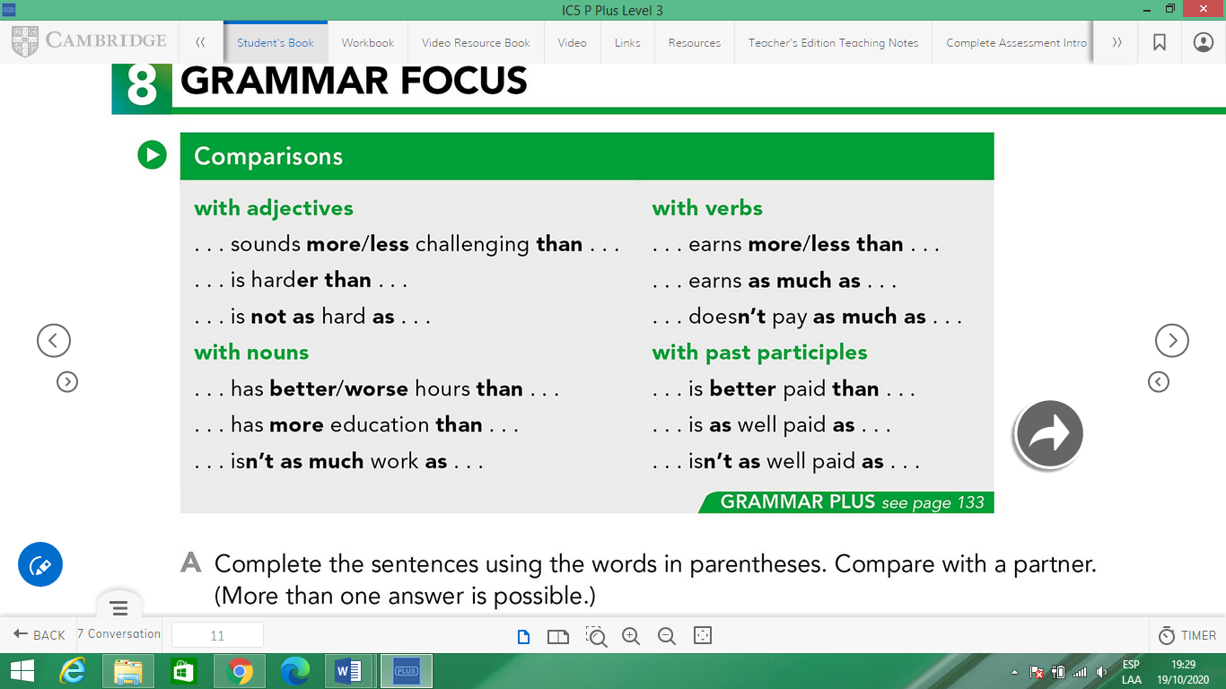

1. **Read these people’s descriptions of their unusual jobs. Then complete the sentences with the phrases in the box.**



|  |  |
| --- | --- |
| better paid than (2x) | more tiring than |
| less money than | not as well paid as |
| more hours than |  |

|  |
| --- |
| 1. Laura Gomez earns            less money than            Emma Wilkins. |
| 2. Laura Gomez is ________________________ Pablo Desillas. |
| 3. Uri Park makes ________________________ Pablo Desillas. |
| 4. Being a dog walker is probably ________________________ being an excuse maker. |
| 5. Joe Stokes is ________________________Emma Wilkins . |
| 6. Uri Park works ________________________ Emma Wilkins. |
| 7. Being a plant entertainer is ________________________ being a greeting-card writer. |

1. **Make comparisons with the information below.**

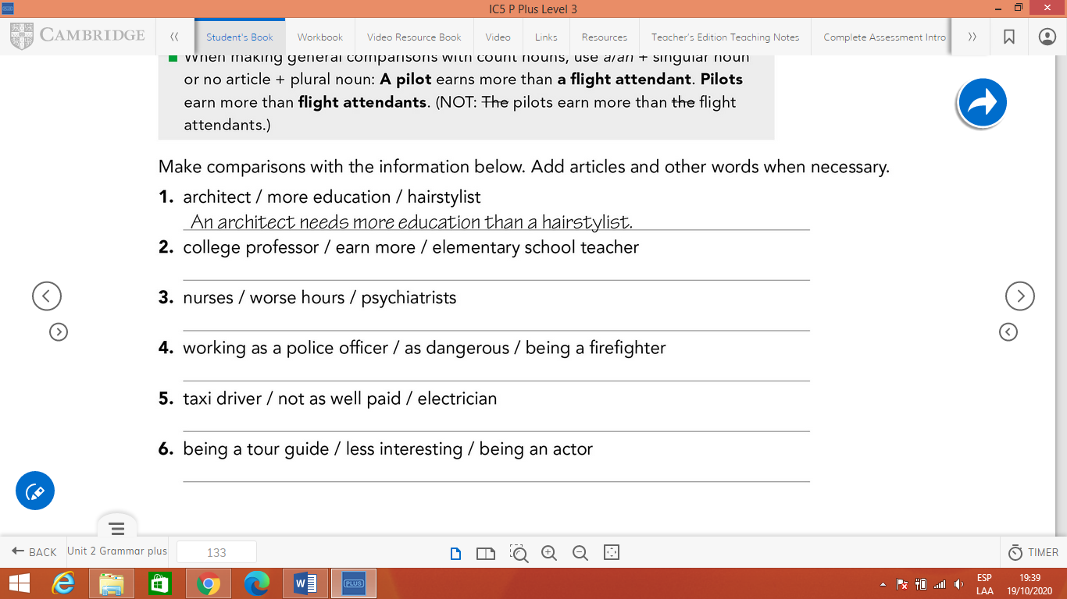

You can write your sentences here.

7. **Use the words in parenthesis to compare the jobs. Check the example.**

