**ESCUELA NORMAL DE EDUCACIÓN PREESCOLAR**

**ENGLISH B1.2 BECOMING INDEPENDENT COMMUNICATORS**

**UNIT 2 – WORKING 9 TO 5**

**READING 1**

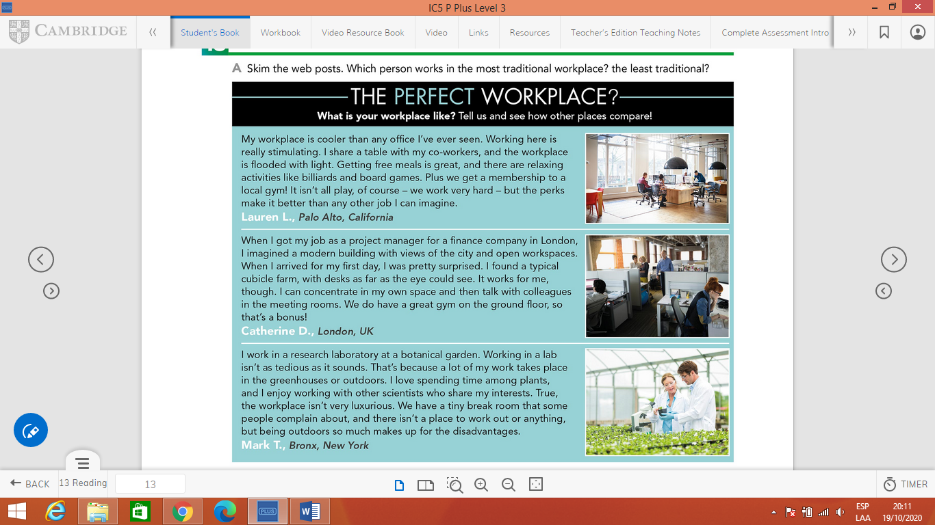

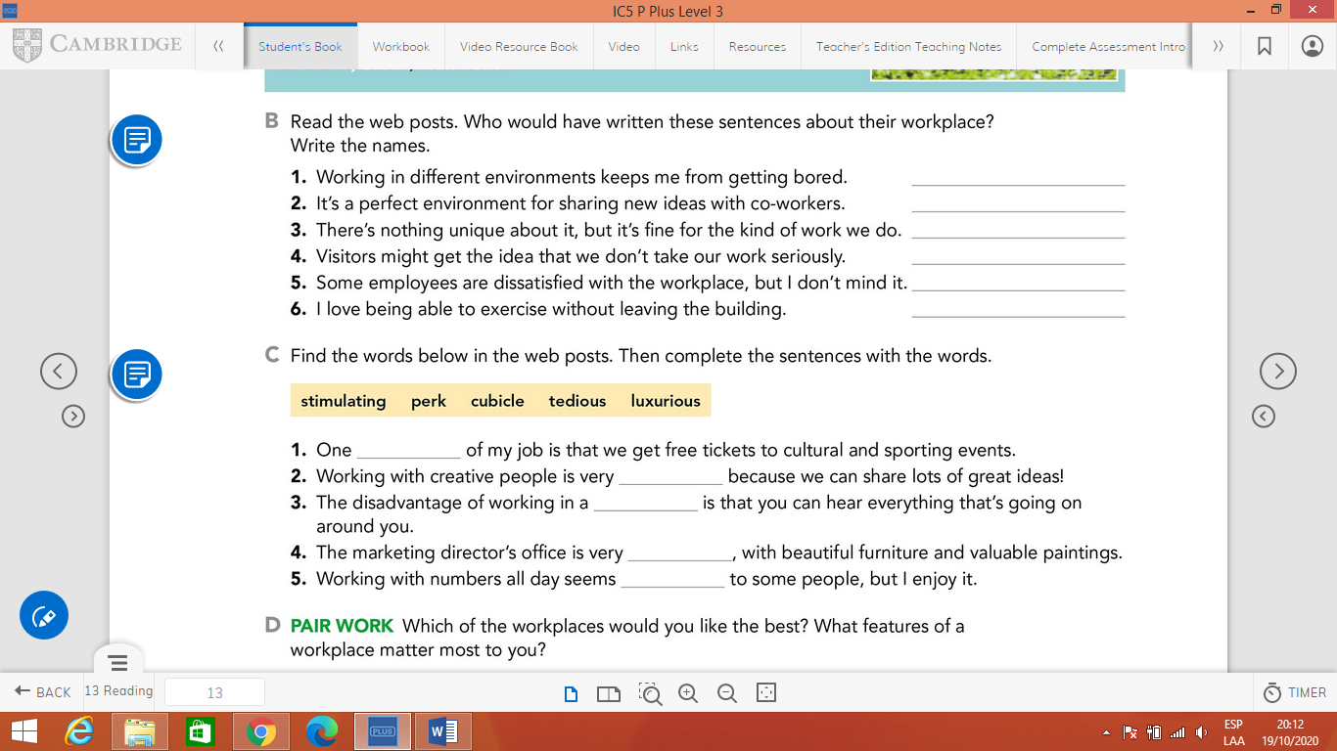

**READING 2**

**Read the magazine interviews. Write the correct job title above each interview. There are two extra jobs.**

