**COVER PAGE**

**TEAM INFORMATION:**

**DATE:**

**ENGLISH III. SHARING INFORMATION AND IDEAS**

**Semester I**

**Learning Evidence**

**Interchange units 1 - 4**

**CELEBRITY DATING GAME**

**A celebrity in search for a special connection**

|  |  |  |
| --- | --- | --- |
| ***Aims:*** | * *Introduce oneself and others, and talk about oneself and learn about others.* * *Ask and answer questions about jobs, and describe routines and daily schedules.* * *Ask about and describe prices and discuss preferences.* * *Discuss entertainment likes and dislikes and make, accept, and decline invitations.* | Game Show The Dating Game Show - Neon Entertainment Booking Agency  Corporate College Entertainment |

**TEAM WORK. Teams of five people (1 host, 1 celebrity and 3 contestants)**

In a dating game show there’s a celebrity on one side of the wall and three contestants on the other side of the wall, so they can´t see each other. And so, the celebrity doesn’t know what the contestants look like. They get to know each other based upon questions and answers. At the end of the game the celebrity has to pick one of those contestants to go on a date with.

**REFERENCE:**

Zooey Deschanel & Michael Bolton Preview 'The Celebrity Dating Game' <https://www.youtube.com/watch?v=x7GfBJ_bvz4>

**1. Plan a ROLE-PLAY**

GROUP WORK   Imagine you are an American television producer and host, creator of the new Dating game show.

Watch the following video and get your creativity flowing. Toni Braxton In "The Dating Game"| The Queen Latifah Show <https://www.youtube.com/watch?v=6JJfsSnGBPo>

The game show needs 1 host, 1 celebrity, 3 contestants and 1 camera woman.

**2. Prepare (BE CREATIVE)**

GROUP WORK   Prepare the game show. Decide who will play each of the roles. Find a costume for the celebrity and host roles. If necessary, ask members from other teams to be part of your team.

Use VOCABULARY and EXPRESSIONS from the course contents UNITS 1, 2, 3 and 4 to create your ROLE-PLAY. Use **follow up expressions** to help the communication flow and sound natural.

The game show must include the following parts:

1. Greetings (Saying hello).
2. Introductions.

* Game description:

“Contestants will answer a series of questions…”

* Must include:
* Giving personal information
* Talking about school / work.
* Talk about daily schedule.

1. Questions – answers.

* Use these questions to learn as much as possible about the contestants.

1. Do you watch / like / play / listen to / go to…?
2. How often do you…?
3. What are some hobbies or activities that give you pleasure?
4. What kinds of…do you…?
5. What musical instrument do you…?
6. What’s your favorite kind of…?
7. When…?
8. Where…?
9. Which…?
10. Who do you like?
11. Who’s your favorite…?
12. Would you like to …?
13. Time is up! Who’s the perfect date?
14. Leave taking (Saying good-bye and thanking the audience).

**FOLLOW UP EXPRESSIONS**

|  |  |  |
| --- | --- | --- |
| 1. Actually, | 8. Let’s see . . . | 15. That’s cool. |
| 2. And you, _Sam_? | 9. Oh, really? | 16. That’s right. |
| 3. And, how about you, _Andy_? | 10. Oh, yeah? | 17. Well . . . |
| 4. And, what about you, _Arleth_? | 11. Oh… | 18. Well, I like… |
| 5. Hey! | 12. OK. | 19. Wow! |
| 6. Hmm. | 13. Really? | 20. Yeah, |
| 7. Let´s | 14. So . . . | 21. That’s cool. |

**3. Present.**

CLASS ACTIVITY   Disguise and perform your game show for the class.

Use the proper intonation. **Reading the dialogue is not valid.**

|  |  |
| --- | --- |
| **DUE TO:** | * **Friday 26th group 1** * **Wednesday Dec 1st group 2** |

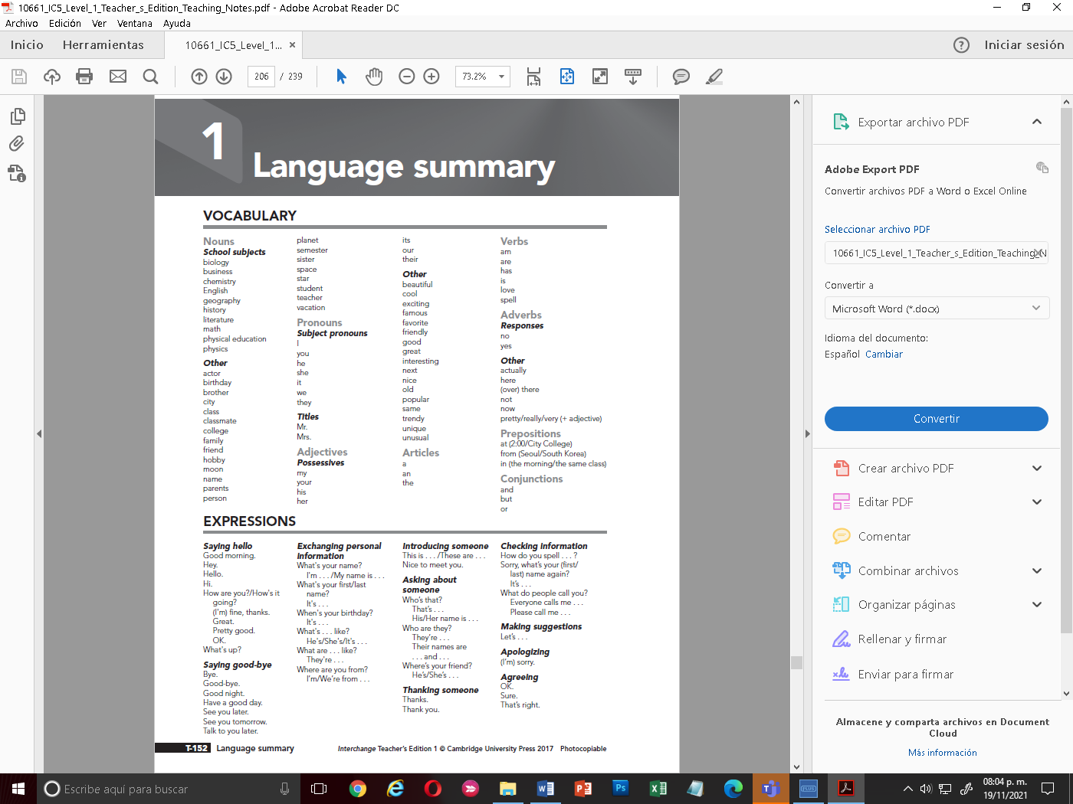 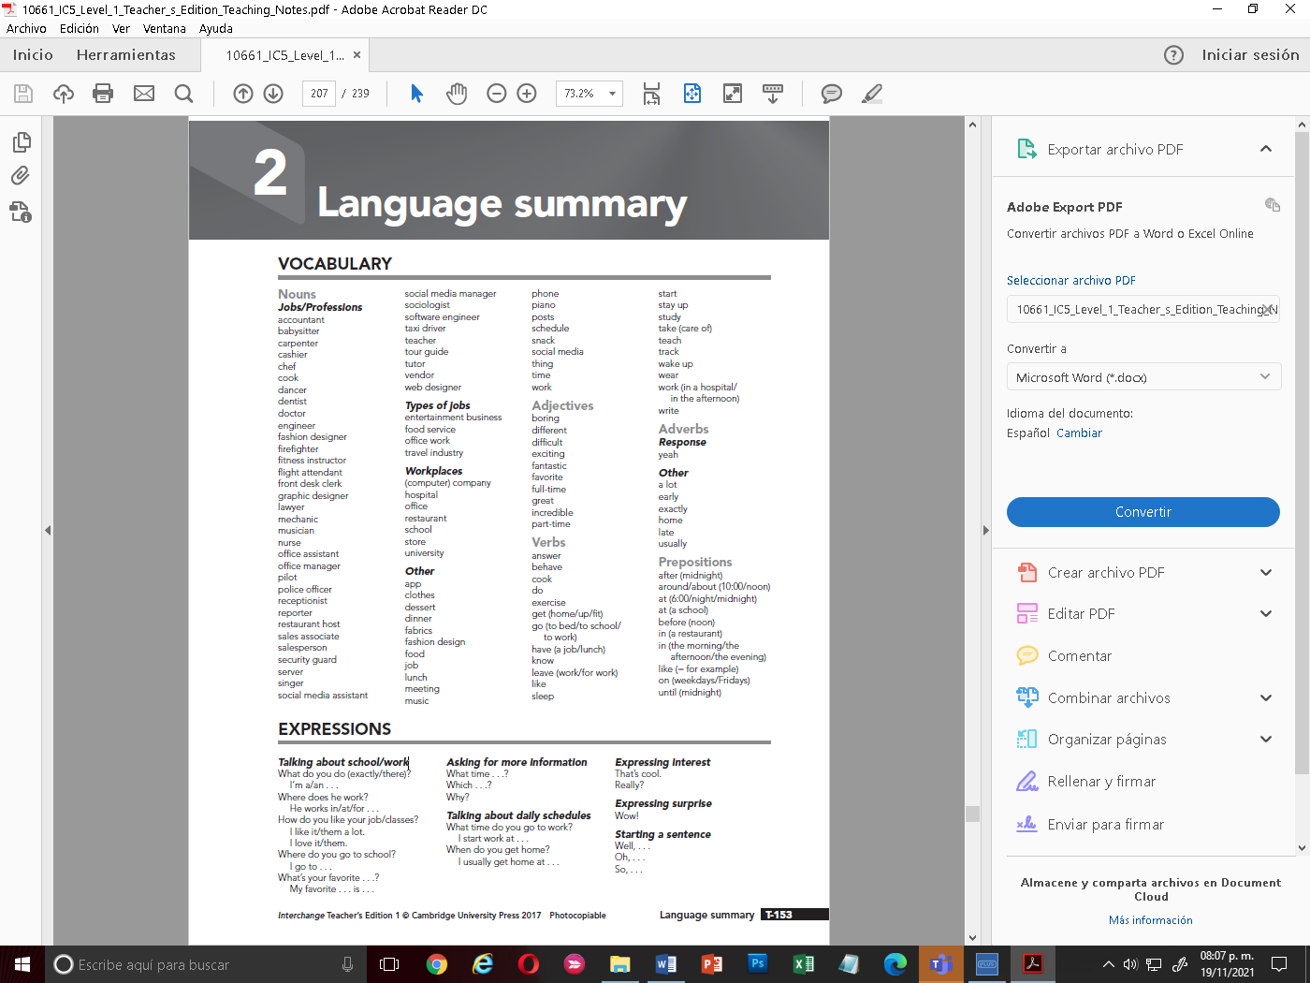

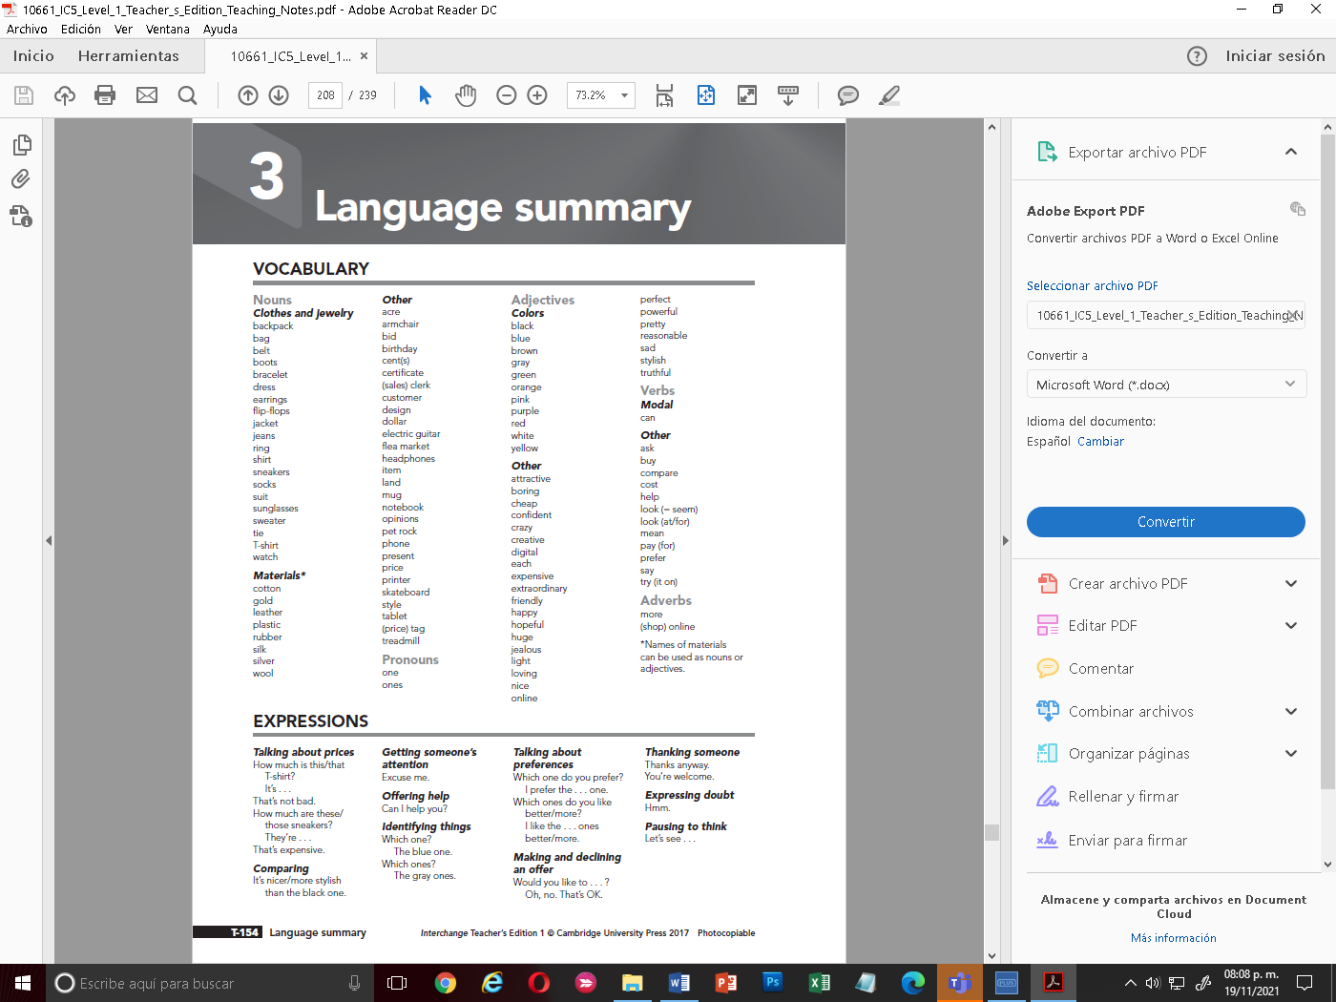 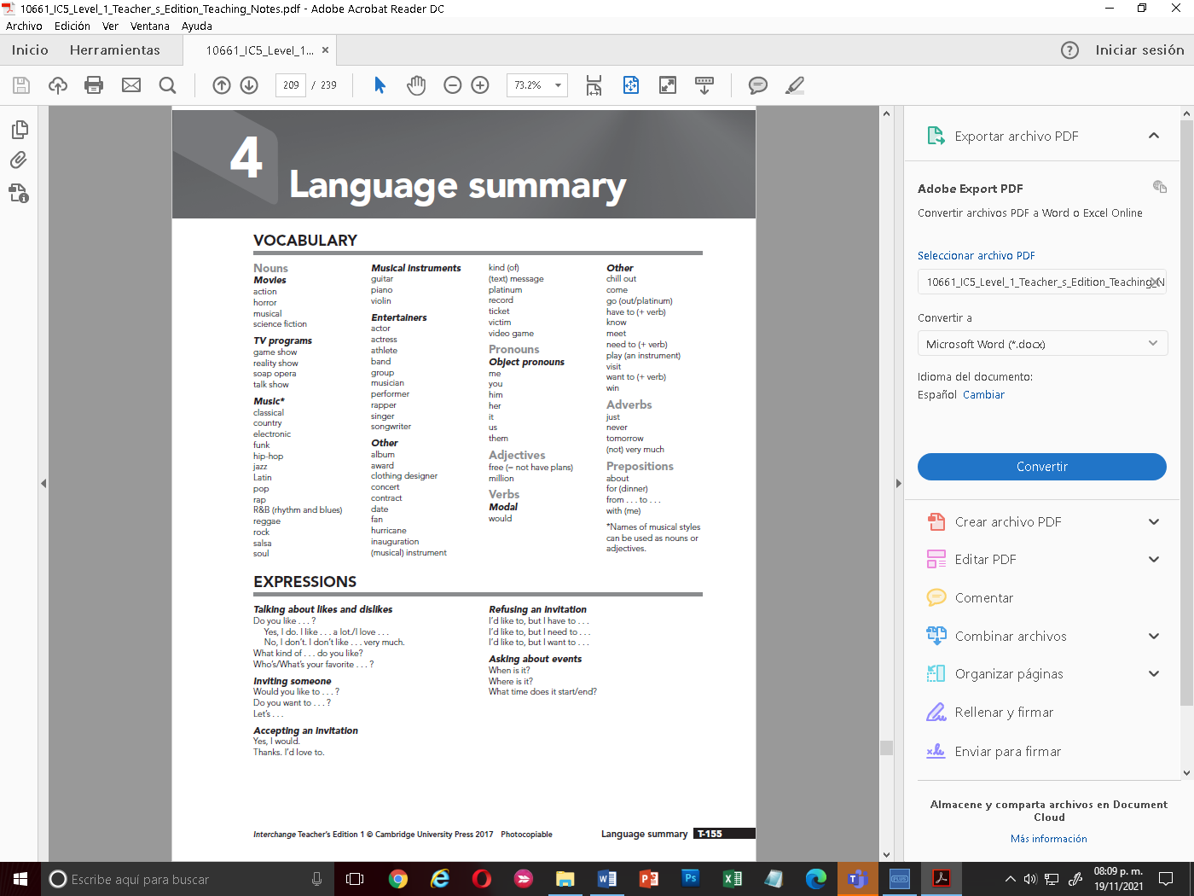

* **SPEAKING EVALUATION CRITERIA**

|  |  |  |  |  |  |  |
| --- | --- | --- | --- | --- | --- | --- |
|  |  | **Poor** | **Fair** | **Good** | **Very good** | **Excellent** |
| **Comprehension** | **0** | **1** | **2** | **3** | **4** | **5** |
| **Fluency** | **0** | **1** | **2** | **3** | **4** | **5** |
| **Grammar** | **0** | **1** | **2** | **3** | **4** | **5** |
| **Vocabulary** | **0** | **1** | **2** | **3** | **4** | **5** |
| **Pronunciation** | **0** | **1** | **2** | **3** | **4** | **5** |
| **Follow instructions** | **0** | **1** | **2** | **3** | **4** | **5** |

**Comprehension - ability to understand questions and respond appropriately.**

**Fluency = ability to speak quickly, naturally, and without many pauses.**

**Grammar = ability to use correct grammar and sentence structure.**

**Vocabulary = ability to understand and use vocabulary words and phrases.**

**Pronunciation = ability to use correct stress, rhythm, and intonation patterns.**

EXCELLENT: 10

VERY GOOD: 9

GOOD: 8

FAIR: 7

POOR: 6

* **WRITING EVALUATION CRITERIA**

|  |  |  |  |
| --- | --- | --- | --- |
| Punctuation and spelling | 1 | 2 |  |
| Correct use of simple grammatical structures | 1 | 2 |  |
| Sufficient vocabulary | 1 | 2 |  |
| Simple connectors and cohesive devices | 1 | 2 |
| Follow instructions | 1 | 2 |
|  |  |  |