**ESCUELA NORMAL DE EDUCACIÓN PREESCOLAR**

**ENGLISH A2.1**

**LEARNING UNIT 3 PROJECT**

**RADIO SHOW**

**Aim:** to give students practice talking about entertainment, and about likes and dislikes.

**Materials:** selection of types of music examples, recorder.

**The preparation activities will be done in class.**

**PLAN**

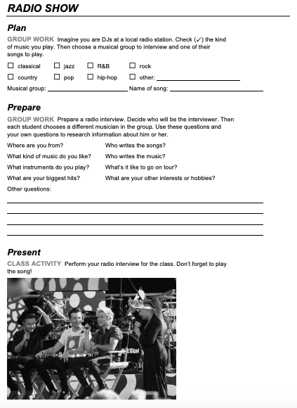

**PREPARE**

Write a **welcome speech** to begin your TV show.

Write some **facts about the guests** to prepare the presentation.

**Prepare an interview.** Decide who will be the interviewer. Then each student chooses a different musician in the group. Use these questions and your own questions to research information about him or her.

1. **Where are you from?**
2. **What kind of music do you like?**
3. **What instruments do you play?**

**Rehearse** your song and make agreements for your performance.

Write a short **closure** for your TV show

**PRESENTATION IN CLASS: Wednesday, January 18th, 2023**

**PROJECT RUBRIC**

|  |  |  |
| --- | --- | --- |
| **PREPARATION TASKS**  **CLASSWORK** | **FINAL PRODUCT** | **SPEAKING PERFORMANCE** |
| **15%** | **35%** | **50%** |

**Checklist – Final product**

|  |  |  |
| --- | --- | --- |
| **FINAL PRODUCT** | **YES** | **NO** |
| The host starts the TV show with a short welcome speech. |  |  |
| The host presents the band providing some facts about them. |  |  |
| The host interviews the guests asking at least 10 questions to research information about them. |  |  |
| The members of the band answer the questions accurately. |  |  |
| The host presents the band before their performance. |  |  |
| The band performs the song in a creative way singing a song in English. |  |  |
| The host closes the TV show with a short speech. |  |  |

**Rubric – Speaking performance**

**4 points 3 points 2 points 1 point**

