UNIT 3. FASHION RUNWAY, What´s your favorite outfit? Due date november 22nd, 2023

Aim: Give Ss practice describing clothes, saying prices, and using comparisons.
Preparation: Make one copy of the worksheet for every group.
Materials: Power point presentation and dressing up for the fashion runway
NOTE: This project is made up of two elements.1) The PP presentation 2) The fashion runway with your favorite outfit.
Present

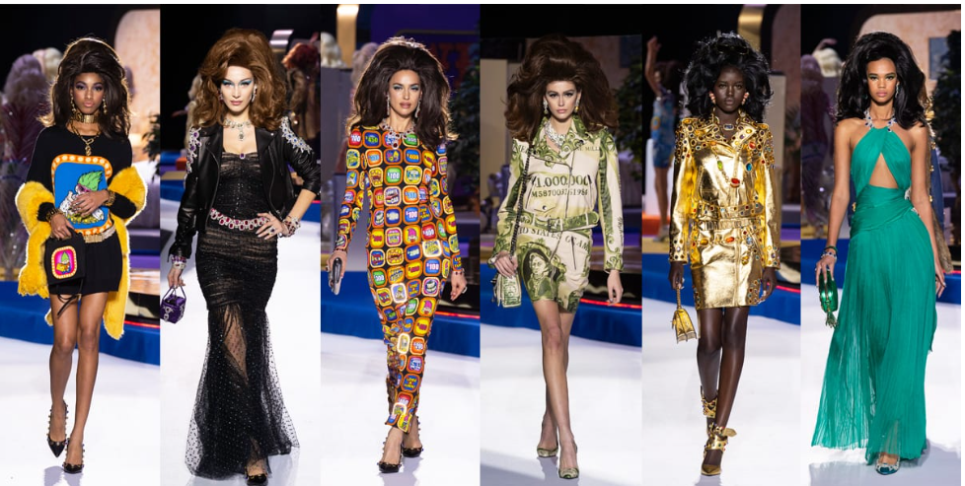
Plan
INDIVIDUAL WORK Go to your closet and choose your favorite outfit (include shoes and accessories). Give reasons of your choice using adjectives. (Jeans are more comfortable and practical. I look more stylish with sunglasses, Big earrings look more fashionable, etc.)
Example: My favorite outfit is made of/consists of a long black silk dress, black high heels, long silver earrings, and silver necklace and bracelet, and a black leather coat in case it gets cold. I love this outfit because it´s more elegant for a nice dinner, or it´s perfect for a party or going to a club. This outfit cost me around $2,300.00 but in dollars it´s about $127.70 (divide the amount in pesos by 18.00)
E.g. (well-paid, working hours are good, nice working environment, etc.)
Prepare
A PAIR WORK . Send a picture of your complete outfit to your classmate and your full description of it like my example above.
B Now, get ready to take your outfit to English class on Wednesday Nov 22nd, for the fashion runway. You will present your classmate. The order of the presentation will be as you appear on the official classroom list.
Prepare what you are going to say about your classmate:
Example: This is my classmate Abril. She´s wearing a beautiful long black silk dress, black leather high heels, leather coat, silver earrings, silver bracelet and silver necklace. She also has a black leather coat in case it gets cold at night. She likes black very much because it´s more elegant than other colors and it´s the perfect outfit for a nice dinner, going to a party or to the night club with friends. This complete outfit costs around $2,300.00 pesos or $127.70 dollars.
Present
CLASS ACTIVITY
1.- .Get ready and dressed to be presented by your classmate. Your classmate has to get ready to present you when it´s your turn. Ok? Here is the class list. Choose your partner to do this project.
AGUILAR ALEMAN FRIDA
AGUILAR PEREZ KAREN ALHELI
ALLENDE MOLINA MARIA EVELIA
BANDA GONZALEZ ANGELA LIZETH
BAZALDUA RAMADAN MARIA FERNANDA
BUSTOS CASTILLO JOSELINE YARELY
FUENTES PUENTE CITLALI ELIZABETH
GAONA CORTES ANDREA JOCELYNE
GOMEZ ARANDA ELISA MARISOL
HERNANDEZ GONZALEZ MELISSA GUADALUPE
HERNANDEZ PICASSO ESTRELLA ESMERALDA
LOPEZ ALVIZO MADELYN
LUIS MARTINEZ MARIA FERNANDA
MONRREAL RAMIREZ LIZBETH CAROLINA
MONTES MORALES JAZMIN GALILEA(PAOLA C. M)
OCHOA CHARLES NAOMI GEORGETTE
OROCIO FLORES VICTORIA
ORTA CARRILLO ANDREA
ORTIZ DE LA ROSA ABRIL ALEJANDRA
PINTOR GONZALEZ LESLIE BERENICE
RAMIREZ MALDONADO LIZZETH GUADALUPE
RAMIREZ RUIZ ALEXA NEFTALI
RAMOS ESQUIVEL FERNANDA YAMILET
RESENDIZ FLORES YARETZI
RICO NUÑEZ GENIS YARETZI
RODRIGUEZ BRIONES DEBANIE GUADALUPE
RODRIGUEZ GONZALEZ AMERICA LIZBETH
RODRIGUEZ VILLANUEVA JESSICA PAULINA
ZUÑIGA MEZA JOCELYN GUADALUPE

2.-Upload a PP/CANVA presentation or Word presentation (Not PDF because I cannot write my comments or observations there) with the following data to Escuela en Red. All the following elements must be included:
- Front cover (name of school and logo, subject (English A2.1), unit number and title of the project, name of teacher, name of student (s), date and place)
- Picture and description of your favorite outfit (one slide per person)
- Each description of the outfit adapted for the class presentation.
- General Conclusion of the project. Tell me what you liked and disliked or learned from it. (both members have to participate in writing this (1 slide)
- Reflection on the learning from the unit. This is done individually. (1 slide) One paragraph per member of the group. Recall all of your learnings.
- Add pictures of the real presentation of your fashion runway.
- Rubric/Self assessed

Enjoy your fashion runway.
Rubric to assess your project. Name of the team members:

Date:
Category | Score 5 | Score 4 | Score 3 | Score 2
Required elements  10 pts | Goes over and above all required elements stated in the instructions | Includes all of the required elements stated in the instructions | Missing one or more of the required elements. | Several required elements are missing from the project
Overall effectiveness and completion of task | Project is organized and presents material captivating for viewer | Project is somewhat organized and complete and holds attention of viewer | Project is disorganized and incomplete at times and is somewhat able to hold attention of viewer | Project is incomplete and not easy to follow
Creativity | Exceptionally unique and clever in showing deep understanding | Thoughtfully and uniquely presented; showing understanding | A few original touches enhance the project to show some understanding of the material | Shows little originality and creativity and/or effort in understanding the material
Neatness and attractiveness | Exceptionally attractive and neat in design and layout | Attractive and neat in design and layout | Acceptably attractive but may be messy at times and/or show lack of organization | Distractingly messy or very poorly designed
Grammar | No grammatical or mechanical mistakes | 2 or 3 grammatical mistakes which are not distracting | 4 to 6 grammatical mistakes which are distracting | More than 6 grammar or mechanical mistakes which are very distracting
Understanding of content | Shows a sophisticated understanding of the themes | Shows an understanding of the themes | Displays a somewhat limited understanding of the themes and may have few misinterpretations | Does not show an understanding of the themes. Has quite a few misinterpretations.
Interview and oral presentation | The interview was creative and included all required aspects. Dressing up was great and clever. | The interview was quite creative and included most of the aspects. Dressing up was good | The interview was somewhat creative and included some of the aspects. Dressing up was ok. | The interview was not really creative and included just a few of the aspects. Dressing up was unsatisfactory.
Total

