**ESCUELA NORMAL DE EDUCACIÓN PREESCOLAR**



**STUDENT’S NAME:** XXXXXXXXXXXXXXXXXX

**COURSE:** ENGLISH B1. OPENING NEW GLOBAL PERSPECTIVES

**LEARNING UNIT 3 EVIDENCE**

**"Invent a helper"**

**COMPETENCES OF THE GRADUATION PROFILE**

Uses critical thinking and creativity to solve problems.

Uses language to establish harmonious and responsible relationships when exercising citizenship.

Reflects on one’s own learning process to act consciously in communicative exchanges.

**SALTILLO, COAHUILA JANUARY 18th, 2024**

**LEARNING UNIT 3 EVIDENCE**

**“Invent a helper” Project**

**Objective:**

* To create an imaginary invention designed to assist with chores.
* To use infinitives and gerunds to describe the functions and usage of their inventions.
* To use imperative and infinitives to give suggestions about their invention.

**Materials Needed:**

* Document with project guidelines and preparation activities.
* Cardboard and items to write (markers, chalks, colors).
* Items and/or recycled material to create an invention.
* Information about using infinitives and gerunds to describe functions, and imperatives and infinitives to give suggestions (book, notebook, extra worksheets).

**Instructions**

**Preparation activities:**

a. Start by discussing common chores and the challenges associated with them.

b. Check the vocabulary and grammar structures addressed in the learning unit and review their usage.

d. Complete the sentences with the correct form of *be used to* or *be used for*.

1. Credit cards **are used to** shop online.

2. Computers ________________________________ sending and receiving emails.

3. The Internet ________________________________ streaming TV.

4. Robots ________________________________ to perform dangerous tasks.

5. A smartphone ________________________________ taking photos.

6. Flash drives ________________________________ storing information.

7. Drones ________________________________ look for criminals.

8. A GPS system ________________________________ get directions.

9. A phone charger ________________________________ charge the battery in a cell phone.

10. An e-reader ________________________________ reading e-books.

e. Choose three items from the boxes. Write four pieces of advice for using each one (use *be sure to, make sure to, remember to, don’t forget to, try not to*).

|  |
| --- |
| ATM card  robot  cell phone  computer  DVD player  flash drive  3-D printer  driverless car  tablet computer  TV |

**EXAMPLE:**

**ATM card**

* *Don’t forget to* change your NIP frequently.
* *Remember to* take your card after you withdraw money from the ATM.
* *Make sure* you don’t share your card numbers with other people.
* *Try not to* use your card information in unknown devices.

**Write your suggestions here.**

**Development activities:**

a. Write five chores you don’t like to do and explain the reason why you don’t like to do them or why you find them difficult.

**1.**

**2.**

**3.**

**4.**

**5.**

b. Brainstorm ideas for inventions that could make these chores easier, faster, or more enjoyable (creativity and variety).

**1. __________________________________________**

**2. __________________________________________**

**3. __________________________________________**

**4. __________________________________________**

**5. __________________________________________**

c. Choose an invention from the list.

**Invention:** ___________________________________________________________________

c. Write ten sentences using *infinitives and gerunds* to describe the uses and purposes of your inventions (*is used to___, can be used for ___).*

**1.**

**2.**

**3.**

**4.**

**5.**

**6.**

**7.**

**8.**

**9.**

**10.**

d. Write ten sentences using *imperatives and infinitives* to give suggestions about your invention (*be sure to, make sure to, remember to, don’t forget to, try not to)*.

**1.**

**2.**

**3.**

**4.**

**5.**

**6.**

**7.**

**8.**

**9.**

**10.**

**Presentation:**

a. Make an advertisement for your invention. Be sure to draw a picture of your invention and list its features.

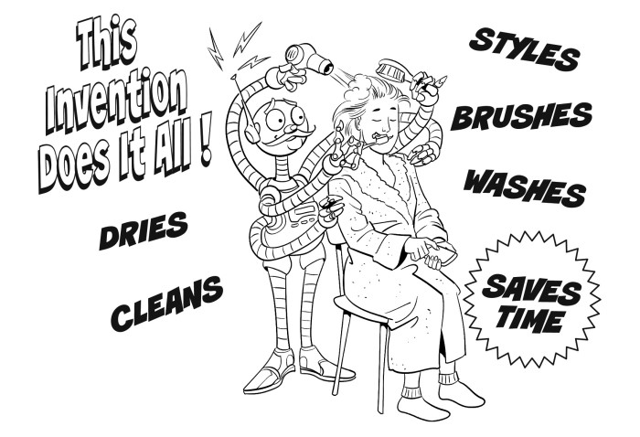

**Paste a picture of your advertisement here.**

c. Build your invention using creative material and be ready to present it in class.

**Paste a picture of your invention here.**

**RUBRIC**

|  |  |  |  |  |  |
| --- | --- | --- | --- | --- | --- |
| **Criteria** | **Excellent (5)** | **Good (4)** | **Average (3)** | **Needs improvement (2)** | **Not delivered** |
| **Creativity in the invention design** | Demonstrates exceptional creativity in the invention design, offering unique and imaginative solutions to the chore. | Shows creativity in the invention design, providing innovative features to address the chore. | Displays some creativity in the invention design, but the features may lack originality. | Lacks creativity; the invention design is generic and lacks innovation. |  |
| **Effective use of infinitives and gerunds in the description** | Accurately and effectively uses a variety of infinitives and gerunds to describe the functions and usage of the invention. | Generally uses infinitives and gerunds appropriately to describe the invention but may show minor errors or inconsistencies. | Demonstrates an attempt to use infinitives and gerunds, but there are noticeable errors or misuse of language. | Inconsistently uses infinitives and gerunds, leading to confusion or lack of clarity in the description. |  |
| **Effective use of infinitives and imperatives to give suggestions** | Accurately and effectively uses a variety of infinitives and imperatives to give suggestions about the invention. | Generally uses infinitives and imperatives appropriately to give suggestions about the invention but may show minor errors or inconsistencies. | Demonstrates an attempt to use infinitives and imperatives to give suggestions about the invention, but there are noticeable errors or misuse of language. | Inconsistently uses infinitives and imperatives to give suggestions about the invention, leading to confusion or lack of clarity in the description. |  |
| **Presentation** | Delivers a well-organized and engaging presentation, effectively communicating the features and benefits of the invention.  Exceptional pronunciation and accent. | Presents the invention in a coherent manner, with good organization and clarity in communication.  Good pronunciation and accent. | Presents the invention, but the organization may be somewhat confusing or the delivery lacks engagement.  Adequate pronunciation and accent. | Struggles to present the invention coherently, resulting in a lack of clarity or interest.  Pronunciation is often unclear, and the accent is strong, affecting comprehension. |  |
| **Overall Presentation** | The document, poster and model of the invention are presented correctly and meet the assignment’s requirements. | The document, poster and model of the invention are presented and meet the assignment’s requirements. | The document, poster and model of the invention are presented and meet most of the assignment’s requirements. | The document, poster and model of the invention are presented and meet some of the assignment’s requirements. |  |
| **TOTAL** | | | | | **/25** |

**REFLECTIVE NOTE**

a. Discuss the strengths and weaknesses of the projects presented in class.

b. Reflect on what you learned from the activity and write a reflective note about the learning outcomes from this project.

|  |  |  |  |
| --- | --- | --- | --- |
| **Learning outcomes** | **Very well** | **OK** | **A little** |
| I can name inventions and objects related to technology. |  |  |  |
| I can use *infinitives* to describe the *uses and purposes of objects*. |  |  |  |
| I can use *gerunds* to describe the *uses and purposes of objects*. |  |  |  |
| I can use *infinitives and imperatives* to *give suggestions*. |  |  |  |

**Write your reflective note here.**