PORTFOLIO LEARNING EVIDENCE PROJECT 2.

Unit 8, Time to Celebrate!

Name: Date:

|  |  |
| --- | --- |
| Aim | Practice describing holidays/celebrations. |
| Plan | Choose an unusual celebration in your country or choose a country you want to learn more about and research an interesting celebration in that country. Answer the questions.   |  |  | | --- | --- | | Who celebrates it?  Where is it celebrated?  Why is it celebrated?  How is it celebrated?  How long does it last? | What do people wear?  What do people eat? Or what food is served?  Is there any music or a special ceremony? | |
| Prepare | Pair work.  Use books, magazines, or the Internet to find the information.  Prepare a presentation about this celebration.  You must include vocabulary and expressions from the **language summary** of the Unit and **relative and adverbial clauses of time**.  Use pictures, costumes, food, or music to explain the tradition. Be creative! |
| Present | Explain the celebration to the class. Share what you learned and be prepared to answer questions. Reading will not be permitted. |
| Products | 1. Oral (speaking) presentation.  2. Power point presentation with only a few words written, loaded up in the Escuela en Red activity. |
| Due date | October 18th, 2018 |
| Grading criteria | **Speaking will be graded as:**   |  |  |  |  |  |  | | --- | --- | --- | --- | --- | --- | | Did the student apply the new functions? (Appropriate) | 0 | .5 | 1 | 1.5 | 2 | | Did the student apply the new vocabulary? (Complete) | 0 | .5 | 1 | 1.5 | 2 | | Was the student Fluent? | 0 | .5 | 1 | 1.5 | 2 | | Was the student Intelligible? (Clear voice) | 0 | .5 | 1 | 1.5 | 2 | | Did the student apply the new structures? (Accurate) | 0 | .5 | 1 | 1.5 | 2 | | TOTAL |  | | | | |   **Written work will be graded as:**   |  |  |  |  |  |  | | --- | --- | --- | --- | --- | --- | | Did the student apply the new functions? (Appropriate) | 1 | 2 | 3 | 4 | 5 | | Did the student apply the new structures? (Accurate) | 1 | 2 | 3 | 4 | 5 | | Did the student apply the new vocabulary? (Complete) | 1 | 2 | 3 | 4 | 5 | | The written work is neat, complete and understandable? | 1 | 2 | 3 | 4 | 5 | | TOTAL |  | | | | | |

**Units 7-8 Progress check**

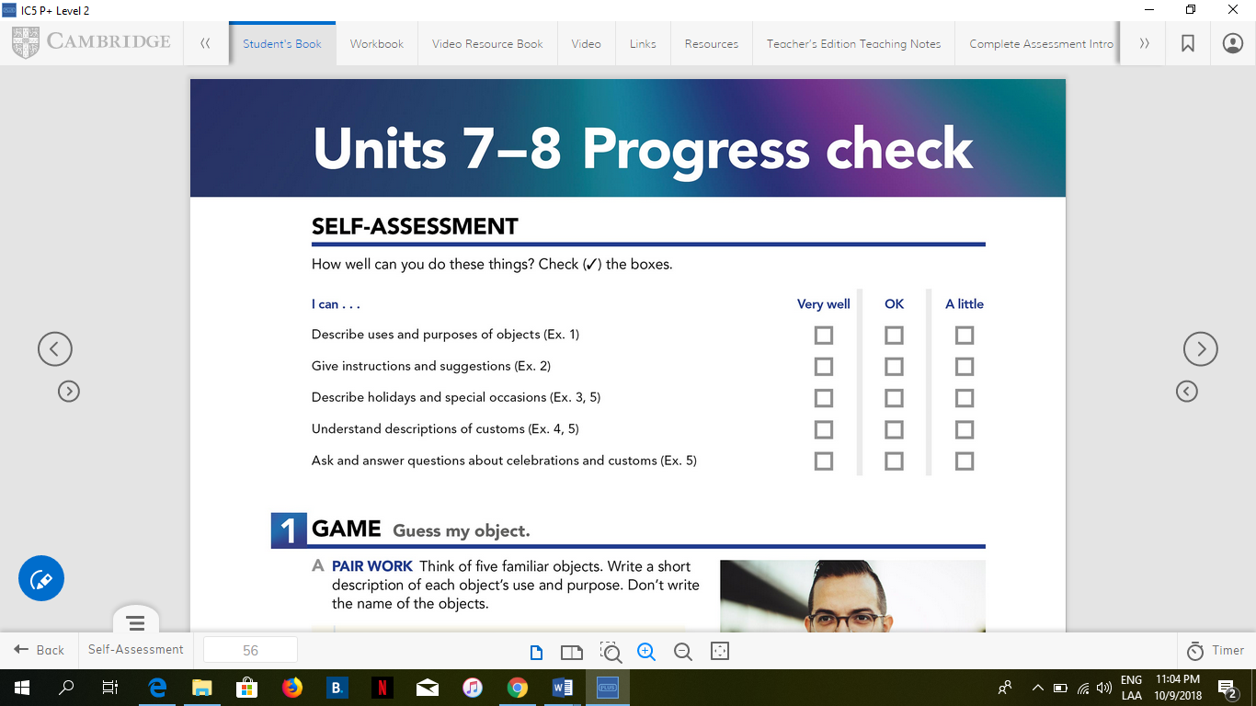

FICHA DE AUTOEVALUACIÓN

|  |  |  |  |
| --- | --- | --- | --- |
| INDICADORES | SIEMPRE | A VECES | CASI NUNCA |
| Muestro interés al realizar mis tareas |  |  |  |
| Planifico y realizo mis tareas con anticipación |  |  |  |
| Presento mis tareas a tiempo |  |  |  |
| Me esfuerzo por superar mis errores |  |  |  |
| Participo activamente en clases |  |  |  |
| Organizo y lidero el equipo de trabajo |  |  |  |
| Me preocupo por superar mis calificaciones |  |  |  |
| Me preparo y leo antes de entrar a clases |  |  |  |
| Consulto frecuentemente mis dudas al profesor |  |  |  |
| Reviso y estudio el tema de la clase anterior. |  |  |  |

FICHA DE COEVALUACIÓN

|  |  |  |  |  |  |
| --- | --- | --- | --- | --- | --- |
| INDICADORES |  | | | | |
|  |  |  |  |  |
| Respeta la opinión de sus compañeros |  |  |  |  |  |
| Ayuda a sus compañeros cuando se lo solicitan |  |  |  |  |  |
| Respeta al docente y a sus compañeros |  |  |  |  |  |
| Cuida y preserva su aula |  |  |  |  |  |
| Llega puntualmente a clase |  |  |  |  |  |
| Fomenta la integración del grupo |  |  |  |  |  |
| Identifica sus logros personales y grupales |  |  |  |  |  |
| Emite juicios valorativos correctos acerca de responsabilidad compromiso y libertad |  |  |  |  |  |

Reflection:

____________________________________________________________________________________________________________________________________________________________________________________________________________________________________________________________________________________________________________.