**Escuela Normal de Preescolar**

**Developing Elementary Conversations**

**Unit 7: “My dream house” Project**

AIM: To identify rooms in the house and furniture.

Note: This project will be done in Pairs

Plan:

1. Draw the outline of a dream house and label each room. You can add details to your house (swiming pool, a fireplace, a big garden with lots of trees and flowers…)
2. Print your poster in tabloid size
3. Cut out pictures of furniture from a magazine or draw and color your own pictures.
4. Laminate the pictures (use contact)

Your poster will look like this:

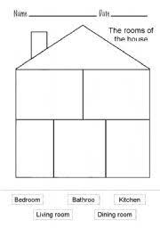

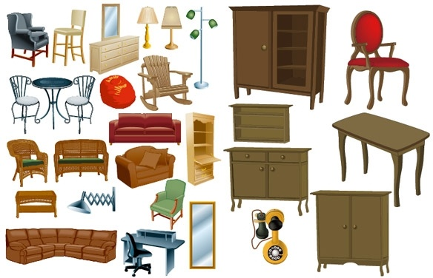 Your cut outs will look like these:

This is the vocabulary you will need to complete your project:

Search for the meaning of the words in a dictionary. Create a pictonary with the vocabulary words.



This project will be done during the week from April 8th to 12th.

You will deliver three products:

1. One poster of a house
2. Furniture cut outs in a Ziploc bag.
3. A Pictionary booklet