**WRITING PROJECT**

**UNIT 7**

**DOES IT HAVE A VIEW?**

**Objective:**

To describe a home using there is/there are and the simple present.

**Preparation:**

Choose a house and write a description of your dream home answering the following questions.

* **What is your dream home?**
* **Where is it?**
* **What rooms does it have?**
* **What things are in the rooms?**
* **Does it have a view?**

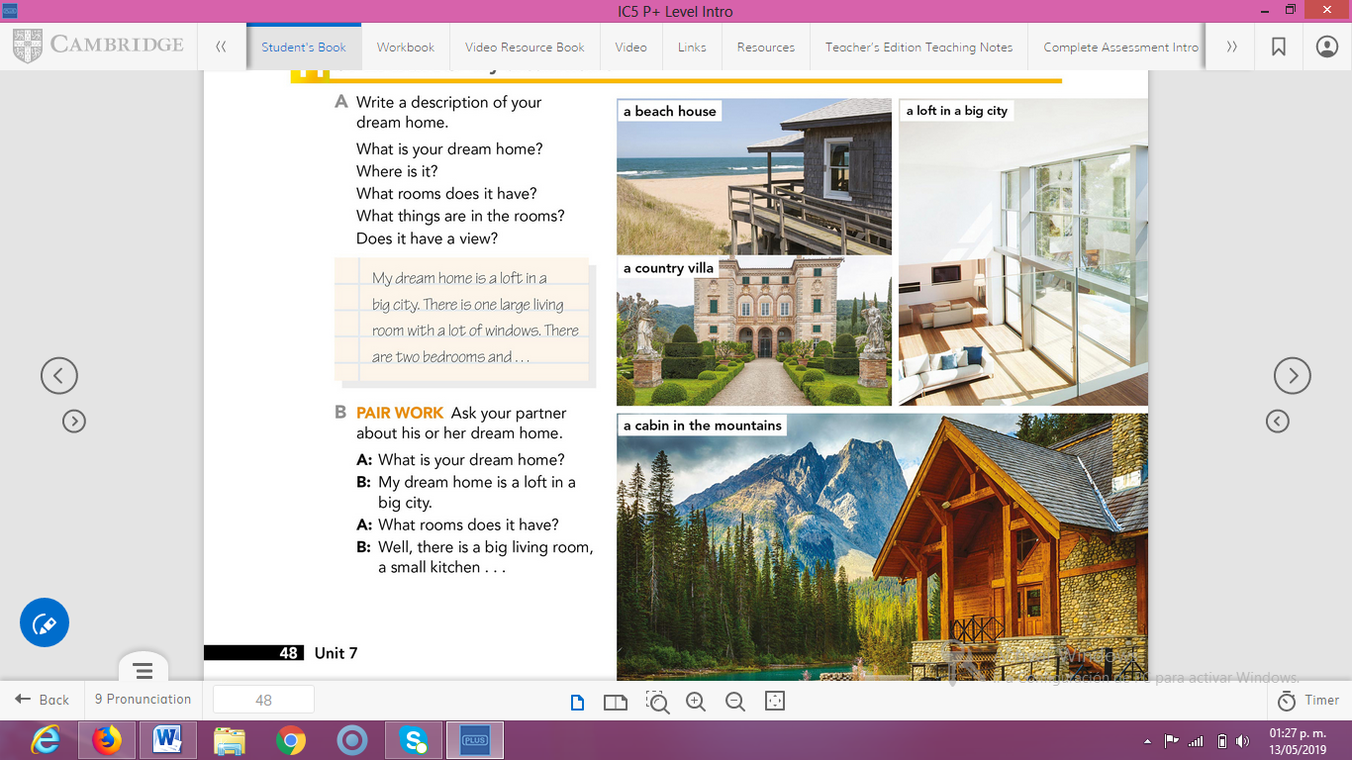

**Product:**

Write a paragraph where you describe your dream home and upload a Word document to Escuela en Red.



|  |  |  |  |  |
| --- | --- | --- | --- | --- |
| CATEGORY | 4 -Very Good | 3 –  Good | 2 - Needs Improvement | 1 –  Unsatisfactory |
| Sentences & Paragraphs | Sentences and paragraphs are complete, well-constructed and of varied structure. | All sentences are complete and well-constructe). Paragraphing is generally done well. | Most sentences are complete and well-constructed. Paragraphing needs some work. | Many sentence fragments or run-on sentences OR paragraphing needs lots of work. |
| Grammar & spelling | Writer makes no errors in grammar or spelling. | Writer makes 1-2 errors in grammar and/or spelling. | Writer makes 3-4 errors in grammar and/or spelling | Writer makes more than 4 errors in grammar and/or spelling. |
| Ideas | Ideas were expressed in a clear and organized fashion. It was easy to figure out what the letter was about. | Ideas were expressed in a pretty clear manner, but the organziation could have been better. | Ideas were somewhat organized, but were not very clear. It took more than one reading to figure out what the letter was about. | The letter seemed to be a collection of unrelated sentences. It was very difficult to figure out what the letter was about. |
| Capitalization and Punctuation | Writer makes no errors in capitalization and punctuation. | Writer makes 1-2 errors in capitalization and punctuation. | Writer makes 3-4 errors in capitalization and punctuation. | Writer makes more than 4 errors in capitalization and punctuation. |