**ESCUELA NORMAL DE EDUCACIÓN PREESCOLAR**



**English level A2.1**

**BUILDING CONFIDENCE IN COMMUNICATION**

**Teacher: Mayela Alejandra del Carmen Gaona García**

**Student’s name: Jenifer Janeth Garcia Escobedo N.L 9**

**BOOK UNIT 4 IT´S THE COLDEST CITY**

**PROJECT: The best place to visit.**

**(Worth 30% of the grade)**

**LEARNING OUTCOMES:**

Students will be able to use the vocabulary of landscapes and adjectives to describe places, the temperatures, distances and measurement use comparatives and superlatives.

**SALTILLO, COAHUILA March 2024**

**Aim:** Write an article about a place in your country that you think tourists would like to visit.

Could be a beach, desert, lake, island, mountain, river. Waterfall or volcano.

Write a paragraph about the place (10 lines) mention the name of the place, when es the best time to go there? why do you recommend the place? Activities you can do there, include adjectives to describe the place measurements and distances (use at least 8 compare or superlative adjectives)

**Materials:** PDF. With the text of the article. (Add a picture of the place)

**Plan: *Individual Work.***

Students are encouraged to develop an article through the practice of the target *vocabulary, grammar, and language functions* of unit 4.

**Prepare.**

* Students will write a short article about a landscape (10 lines).
* Students choose a place of their preference (any natural landscape around the world)
* Use at least three words of natural landscapes.
* Use adjectives to describe the mentioned places.
* Use comparatives and superlatives include adjectives to describe temperatures, distances and measurement (at least 4 of each)
* Be creative to edit your text and include pictures.
* Upload your article in Escuela en red.

|  |  |
| --- | --- |
| **General Requirement** | **Example of the article (student´s book pg 96 ex 14)** |
| **Vocabulary Unit 4**   * Vocabulary of landscapes (at least 3 words) * Description of the natural landscape (at least 3 definitions) |  |
| **Grammar and language functions**   * Use comparatives to describe temperatures, distances and measurement (at least 4) * Use superlatives to describe temperatures, distances and measurement (at least 4) |
| **Format**   * Coversheet * 10 lines min in PDF format * Creativity * Include self-assessment |

https://youtu.be/IV2QpLdOZ7k

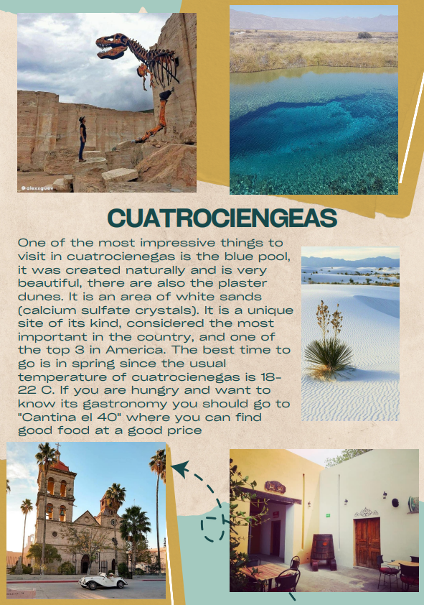

**SELF-ASSESSMENT**

|  |  |  |  |
| --- | --- | --- | --- |
| **How well do you do these things?** | **Very well** | **OK** | **a little** |
| Identify and use vocabulary of landscapes |  |  |  |
| Give a definition or describe with words a natural landscape |  |  |  |
| Use comparatives adjectives to describe temperature, distance or measurements. |  |  |  |
| Use superlatives adjectives to describe temperature, distance or measurements. |  |  |  |
| Use questions with how to ask about temperature, distance or measurements. |  |  |  |

|  |
| --- |
| **What can you do to improve? (opportunities)** |