**GOBIERNO DEL ESTADO DE COAHUILA DE ZARAGOZA**

**SECRETARÍA DE EDUCACIÓN PÚBLICA**

ESCUELA NORMAL DE EDUCACIÓN PREESCOLAR



[**INGLÉS.**](http://187.141.233.82/sistema/ActividadSalon/Cartera.asp?e=enep-00048&c=1674507163&p=46B7219B6631M13255M3104MBA&idMateria=7508) **COMUNICACIÓN BÁSICA**

ACTIVIDADES

**PRESENTADO POR:**

EMILY KARINA VAZQUEZ SOSA #24

**MAESTRA:**

MARIA ELENA MEZA AGUADO

**SALTILLO, COAHUILA DE ZARAGOZA FEBRERO 2024**

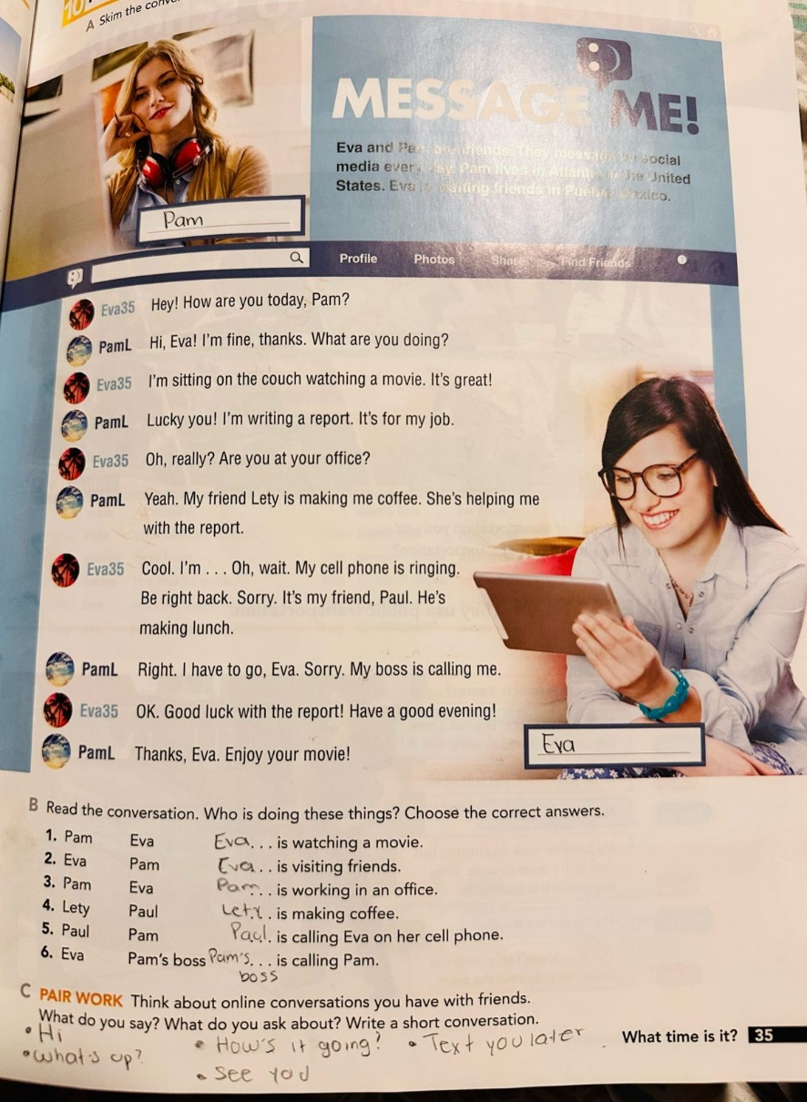ACTIVITY 1.

ACTIVITY 2.

Emily: Hi Nicky, long time no talk on the phone!   
Nicky: Hey Emily! How are you doing?

Emily: I’m fine, busy with school… And you? It’s good to see you.

Nicky: I’m good, thanks. Let’s meet this weekend to catch up!

Emily: Sounds good, I’ll text you to confirm the place and time ok?

Nicky: Perfect.

Emily: Hey, what time is it?

Nicky: Hmm, is it 8 o´clock.

Emily: Thanks, sorry, I´m going to studying, I have a test, tomorrow.

Nicky: Oh, that´s okay, good luck.

Emily: Thanks, I love you, best friend.

Nicky: See you soon.

Verbs

Expressions