AYLIN ESTEFANIA REYES ESQUIVEL #19
Book page 35
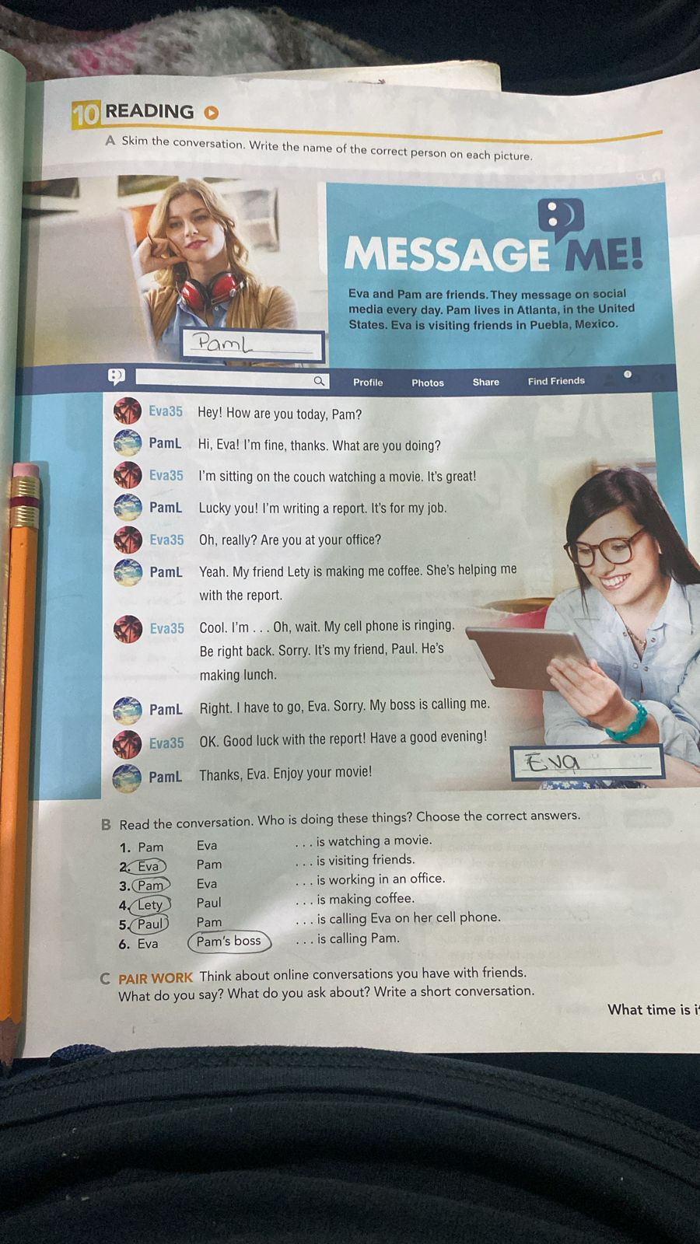

conversation

Anapaú’s: Hey Aylin!!! You know where is Valeria?
AylinA: Hello Ana pau! Mm I don’t know she’s not connected??
Anapau’s: Mm I think not but, What are you doing today, Aylin?
AylinA: Im listening music an everything is great!! And what are you doing??
Anapau’s: Lucky you!! I’m little stressed doing homework so I’m looking for Valeria
Anapau’s: …Oh wait it seems that she is writing
Baleria: HELLO!! What’s happening?
Anapau’s: You finally appear!! I need your help
Baleria: Ohhh, I’m really sorry! I had forgotten
Baleria: Let’s do the homework!!
Anapau’s: Cool let’s do it
AylinA: Good luck whit your homework!!
Anapau’s: Thanks, Aylin Enjoy your free time!!
Baleria: Will be right back!!

