**ESCUELA NORMAL DE EDUCACIÓN PREESCOLAR**



**STUDENT’S NAME: ALONSO MORENO NATALIA MONSERRAT**

**COURSE:** ENGLISH B1. OPENING NEW GLOBAL PERSPECTIVES

**LEARNING UNIT 3 EVIDENCE**

**"Storytelling"**

**COMPETENCES OF THE GRADUATION PROFILE**

Uses critical thinking and creativity to solve problems.

Uses language to establish harmonious and responsible relationships when exercising citizenship.

Reflects on one’s own learning process to act consciously in communicative exchanges.

**SALTILLO, COAHUILA JUNE 18TH, 2024**

**LEARNING UNIT 3 EVIDENCE**

**Storytelling**

**Objective:**

* To practice using when and while.
* To practice using the present tenses, the simple past tense and the past continuous to tell stories.

**Instructions**

**Preparation activities:**

1. Start by **reviewing** the information we practiced in class about grammar structures for the simple past tense, the past continuous and the use of while and when to tell stories.
2. **Provide examples** of both structures in class and do the **speaking activities** in teams.
3. **Go** to <https://www.liveworksheets.com/es/w/en/english-second-language-esl/2237625> and **complete** the exercise to practice all the contents addressed in the unit.

**PASTE A SCREENSHOT OF YOUR RESULT HERE.**

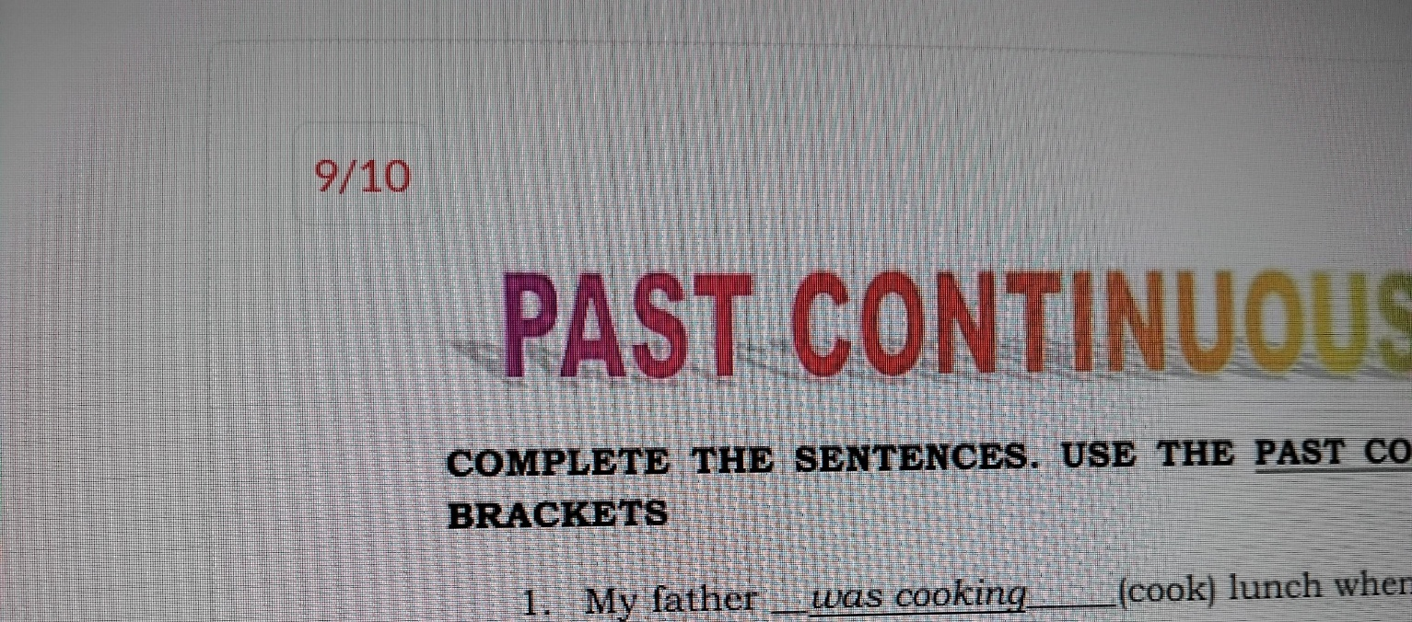

1. Write an adverb from the box to complete the sentences. More than one adverb could be correct.

coincidentally sadly strangely

fortunately ~~suddenly~~  surprisingly

luckily miraculously unexpectedly

unfortunately

**Ex.** My sister was driving to school when *suddenly* she got a flat tire.

**1.** Last weekend my best friend lost her ID while she was shopping, **fortunately** someone found it and gave it to the cashier.

**2.** My cat was very sick, the vet was checking her vital signs, when, **miraculously**, she got better and started walking and playing.

3. We were having a party when, **surprisingly**, the lights went out.

4. I was dancing at the party when, **unfortunately**, I fell down!

5. My dog and I were alone at home when, **strangely**, he barked to the wall.

**Development and presentation activities**

1. **Find five pictures** of people, places or things in magazines, newspapers or the internet, they should not have anything to do with each other. **Paste them in a word document** and **send** them to the student chosen by the teacher.

**PASTE YOUR PICTURES HERE**

1. You must **write a story** connecting the five pictures following the next activities. Be creative and imagine other characters or events that are not in the pictures to make the story more interesting. Remember to use sequence words (first, next, then, last, finally, at the beginning, after that), as well as grammar structures and adverbs for storytelling from the previous exercises.

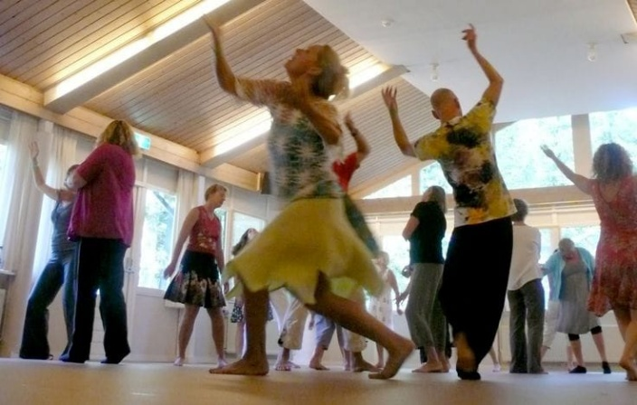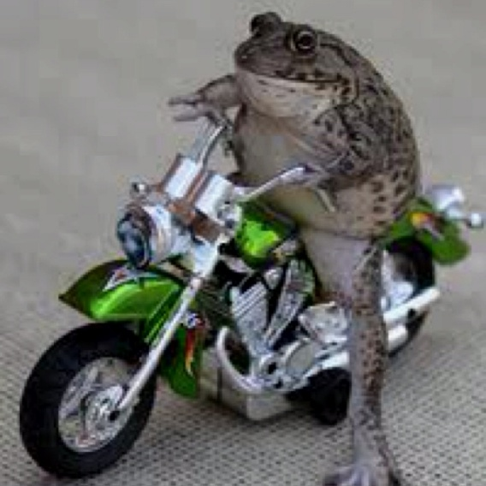

**STEP 1. PLAN**

|  |  |  |  |  |
| --- | --- | --- | --- | --- |
| **CHARACTERS** | **SETTING** | | **TIME** | |
| *Who?*  *Naugthy spy (frog)* | *Where?*  *In a party and then in a street* | | *When?*  *In the afternoon* | |
| **MAIN PROBLEM** | *What happened?*  *The spy needs to get into the party of the evil katty cat* | | | |
| **SOLUTION** | *How the problem was fixed?*  *The spy get the diamon* | | | |
| **STORY PLOT** | | | | |
| **FIRST** | | **THEN** | | **LAST** |
| The frog goes to the party | | The frog trick the cat | | The frog run away in his motorcycle |

**STEP 2. WRITE**

**Write a story** connecting the five pictures following the next activities. Be creative and imagine other characters or events that are not in the pictures to make the story more interesting. Remember to use sequence words (first, next, then, last, finally, at the beginning, after that), as well as grammar structures and adverbs for storytelling from the previous exercises. **THE STORY MUST HAVE ALL THE PICTURES PROVIDED BY YOUR CLASSMATE AND AT LEAST 150 WORDS.**

**WRITE YOUR STORY HERE**

This story begins with the amazing spy froggy, she is incredible strong, and she can do anything that a frog can do, because she is a frog. First, one day froppy was walking to the job in the morning, when strangely her boss “koya” called her to the office. His said: “We need your help, because an evil cat named Katty cat stole the stronger diamond in the world, this diamond can control anything, it`s extremely dangerous” and froggy said: “How can I help?”

This is how froggy infiltered in the party, she was dressed in a beautiful black smoking, while someone approached and touched her shoulder, ¡it was Katty cat! She smiled at her, but for some reason looked fake, they talked a little, fortunately, froggy was thinking how steal the diamond, when she realized that it was not a party, it was a ritual. While froggy was surprised, Katty cat said “Finally our star arrived, froggy will be the sacrifice”

Then, froggy was fighting with the bodyguards, when got up the diamond and she ran away in her Motocycle, she was driving when she finally hid in a Italy street, once away, froggy saved the day with the diamond.

**STEP 3. TELL YOUR STORY**

* **Record** yourself reading your story aloud and save the file.
* Upload the audio file to a web platform and paste the link in this space.
* Share your story with your classmates, they will listen to it and make comments about it.
* …

https://youtu.be/GCCzWwfD9z8?si=U9qKFrabe0iu_4EZ

**REFLECTIVE NOTE**

a. Reflect on what you learned from the activity and write a reflective note about the learning outcomes from this project. Write about what you are able to do and what you have to practice more.

**Write your reflective note here.**

**Aprender inglés como docente en formación es crucial en un mundo globalizado donde la comunicación a través de diferentes idiomas cada vez más común. Dominar un idioma permite acceder a recursos educativos y metodologías innovadoras, facilita la colaboración internacional y amplía las oportunidades profesionales. Además, fortalece la capacidad de enseñar a estudiantes con diversos orígenes lingüísticos, promoviendo la inclusión y la equidad educativa.**

**PROJECT RUBRIC**

|  |  |  |
| --- | --- | --- |
| **PREPARATION TASKS** | **WRITING ASSIGNMENT** | **SPEAKING PERFORMANCE** |
| **10%** | **50%** | **40%** |
| **10%** | **46.5%** | **32%** |

**Rubric – Writing assignment**

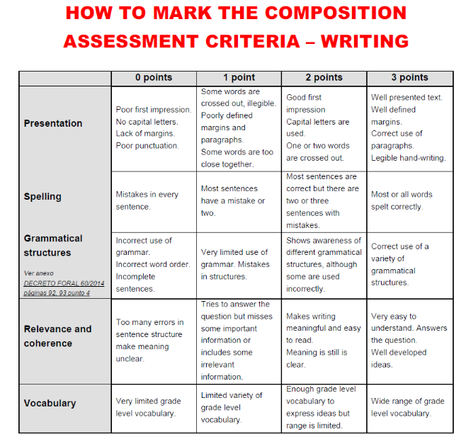

**Rubric – Speaking performance**

