**ESCUELA NORMAL DE EDUCACIÓN PREESCOLAR**



**STUDENT’S NAME:** ANDREA GAYTAN BERMEA

**COURSE:** ENGLISH B1. OPENING NEW GLOBAL PERSPECTIVES

**LEARNING UNIT 3 EVIDENCE**

**"Storytelling"**

**COMPETENCES OF THE GRADUATION PROFILE**

Uses critical thinking and creativity to solve problems.

Uses language to establish harmonious and responsible relationships when exercising citizenship.

Reflects on one’s own learning process to act consciously in communicative exchanges.

**SALTILLO, COAHUILA JUNE 18TH, 2024**

**LEARNING UNIT 3 EVIDENCE**

**Storytelling**

**Objective:**

* To practice using when and while.
* To practice using the present tenses, the simple past tense and the past continuous to tell stories.

**Instructions**

**Preparation activities:**

1. Start by **reviewing** the information we practiced in class about grammar structures for the simple past tense, the past continuous and the use of while and when to tell stories.
2. **Provide examples** of both structures in class and do the **speaking activities** in teams.
3. **Go** to <https://www.liveworksheets.com/es/w/en/english-second-language-esl/2237625> and **complete** the exercise to practice all the contents addressed in the unit.

**PASTE A SCREENSHOT OF YOUR RESULT HERE.**

1. Write an adverb from the box to complete the sentences. More than one adverb could be correct.

coincidentally sadly strangely

fortunately ~~suddenly~~  surprisingly

luckily miraculously unexpectedly

unfortunately

**Ex.** My sister was driving to school when *suddenly* she got a flat tire.

**1.** Last weekend my best friend lost her ID while she was shopping, ____when **fortunately** __ someone found it and gave it to the cashier.

**2.** My cat was very sick, the vet was checking her vital signs, when, _ **miraculously** __, she got better and started walking and playing.

3. We were having a party when, _ **unexpectedly** __, the lights went out.

4. I was dancing at the party when, _ **unfortunately**, I fell down!

5. My dog and I were alone at home when, _ **strangely** ___, he barked to the wall.

**Development and presentation activities**

1. **Find five pictures** of people, places or things in magazines, newspapers or the internet, they should not have anything to do with each other. **Paste them in a word document** and **send** them to the student chosen by the teacher.

**PASTE YOUR PICTURS HERE**

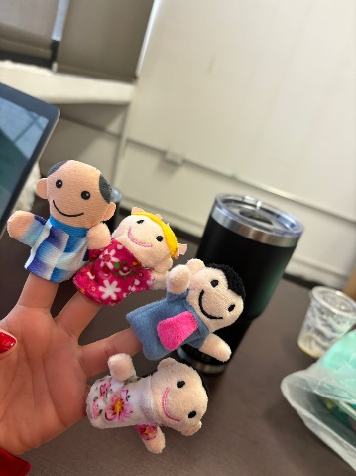

1. You must **write a story** connecting the five pictures following the next activities. Be creative and imagine other characters or events that are not in the pictures to make the story more interesting. Remember to use sequence words (first, next, then, last, finally, at the beginning, after that), as well as grammar structures and adverbs for storytelling from the previous exercises.

**STEP 1. PLAN**

|  |  |  |  |  |
| --- | --- | --- | --- | --- |
| **CHARACTERS** | **SETTING** | | **TIME** | |
| *AIME*  *FATHER- MARIO*  *MOTHER- BETTY*  *BROTHER- JOSE*  *BABY- XIMENA*  *A DOG- LOLA*  *3 FRIENDS* | *TAJ MAHAL* | | *5 YEARS AGO,* | |
| **MAIN PROBLEM** | *One of the friends turned into a monster and scared the family* | | | |
| **SOLUTION** | *the family pet saves the brothers* | | | |
| **STORY PLOT** | | | | |
| **FIRST** | | **THEN** | | **LAST** |
| First, family and friends meet at a restaurant | | The family invites friends to their house and it is where the events happen | | the pet saves the brothers |

**STEP 2. WRITE**

**Write a story** connecting the five pictures following the next activities. Be creative and imagine other characters or events that are not in the pictures to make the story more interesting. Remember to use sequence words (first, next, then, last, finally, at the beginning, after that), as well as grammar structures and adverbs for storytelling from the previous exercises. **THE STORY MUST HAVE ALL THE PICTURES PROVIDED BY YOUR CLASSMATE AND AT LEAST 150 WORDS.**

**WRITE YOUR STORY HERE**

**First, 5 years ago, a family that lived in India, was walking around the Taj Mahal, they were celebrating Mother Betty's birthday in a restaurant.**

**After a few minutes passed, they met some friends of their eldest son Jose, so they invited them to join them while they were eating.**

**So, their mother invited them to her house to spend the day with them, and their friends said yes.**

**They arrived at the family's house while one of the friends began to feel bad.**

**They were talking in the living room about their lives when the friend who was feeling bad went to the bathroom because she continued to feel uncomfortable.**

**strangely, she began to become Aime, a woman that appearance terrified anyone.**

**While the family was talking with the guests, Aime came out, scaring the family's baby. Then the pet named Lola heard that the baby was crying, when suddenly the family ran while Aime tried to scare the baby. Lola was trying to remove Aime, when her parents arrived and managed to get her out.**

**Finally, Aime falls asleep running while the family celebrated that Lola had saved the baby. end**

**STEP 3. TELL YOUR STORY**

* **Record** yourself reading your story aloud and save the file.
* Upload the audio file to a web platform and paste the link in this space.
* Share your story with your classmates, they will listen to it and make comments about it.

Link

<https://youtu.be/4aCj77XAaPo?si=PHiagyeqMpXO7GZg>

**REFLECTIVE NOTE**

a. Reflect on what you learned from the activity and write a reflective note about the learning outcomes from this project. Write about what you are able to do and what you have to practice more.

**Write your reflective note here.**

**Durante está unidad de aprendizaje logré conocer y poner en práctica el pasado simple junto con el presente continuo para describir acciones pasadas esto fue posible gracias a las clases y las explicaciones de la maestra junto con la práctica progresiva de todas las clases**

**PROJECT RUBRIC**

|  |  |  |
| --- | --- | --- |
| **PREPARATION TASKS** | **WRITING ASSIGNMENT** | **SPEAKING PERFORMANCE** |
| **10%** | **50%** | **40%** |
| **10%** | **43%** | **26%** |

**Rubric – Writing assignment**

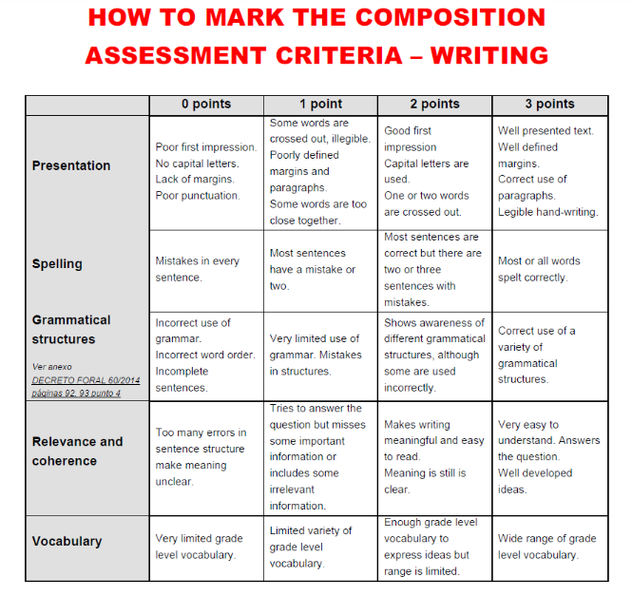

**Rubric – Speaking performance**

