**ESCUELA NORMAL DE EDUCACIÓN PREESCOLAR**



**STUDENT’S NAME:** Perla Carolina Ruiz Cisneros #24

**COURSE:** ENGLISH B1. OPENING NEW GLOBAL PERSPECTIVES

**LEARNING UNIT 3 EVIDENCE**

**"Storytelling"**

**COMPETENCES OF THE GRADUATION PROFILE**

Uses critical thinking and creativity to solve problems.

Uses language to establish harmonious and responsible relationships when exercising citizenship.

Reflects on one’s own learning process to act consciously in communicative exchanges.

**SALTILLO, COAHUILA JUNE 18TH, 2024**

**LEARNING UNIT 3 EVIDENCE**

**Storytelling**

**Objective:**

* To practice using when and while.
* To practice using the present tenses, the simple past tense and the past continuous to tell stories.

**Instructions**

**Preparation activities:**

1. Start by **reviewing** the information we practiced in class about grammar structures for the simple past tense, the past continuous and the use of while and when to tell stories.
2. **Provide examples** of both structures in class and do the **speaking activities** in teams.
3. **Go** to <https://www.liveworksheets.com/es/w/en/english-second-language-esl/2237625>
4. and **complete** the exercise to practice all the contents addressed in the unit.

**PASTE A SCREENSHOT OF YOUR RESULT HERE.**

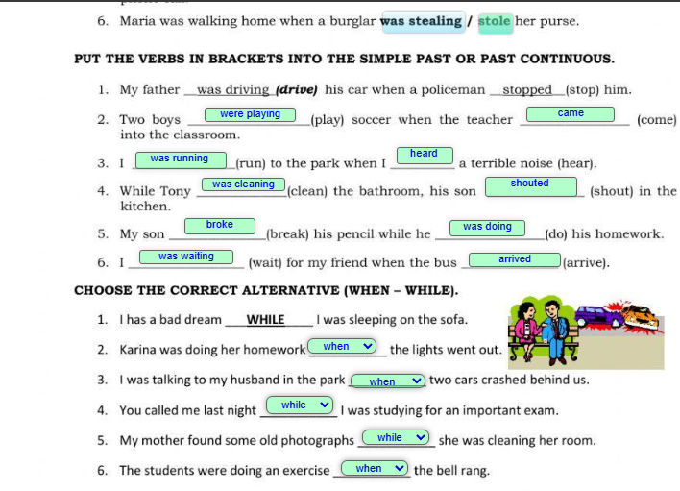

1. Write an adverb from the box to complete the sentences. More than one adverb could be correct.

coincidentally sadly  ~~strangely~~

fortunately ~~suddenly~~  surprisingly

~~luckily~~  ~~miraculously~~  unexpectedly

~~unfortunately~~

**Ex.** My sister was driving to school when *suddenly* she got a flat tire.

**1.** Last weekend my best friend lost her ID while she was shopping, *luckily* someone found it and gave it to the cashier.

**2.** My cat was very sick, the vet was checking her vital signs, when, *miraculously*, she got better and started walking and playing.

3. We were having a party when, *sadly* the lights went out.

4. I was dancing at the party when, *unfortunately* I fell down!

5. My dog and I were alone at home when, *strangely,* he barked to the wall.

**Development and presentation activities**

1. **Find five pictures** of people, places or things in magazines, newspapers or the internet, they should not have anything to do with each other. **Paste them in a word document** and **send** them to the student chosen by the teacher.

**PASTE YOUR PICTURES HERE**

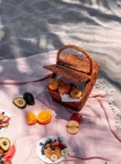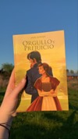

1. You must **write a story** connecting the five pictures following the next activities. Be creative and imagine other characters or events that are not in the pictures to make the story more interesting. Remember to use sequence words (first, next, then, last, finally, at the beginning, after that), as well as grammar structures and adverbs for storytelling from the previous exercises.

**STEP 1. PLAN**

|  |  |  |  |  |
| --- | --- | --- | --- | --- |
| **CHARACTERS** | **SETTING** | | **TIME** | |
| *Who?*  2 Dogs  1 hamster | *Where?*  Field | | *When?*  One year ago. | |
| **MAIN PROBLEM** | *What happened?*  The hamster Rogelio and Pequita Dog are two friends, who have an argument with Luisa Dog because of a picnic day. | | | |
| **SOLUTION** | *How the problem was fixed?*  The hamster Rogelio and Pequita Dog made a special meal and contron some stories for Luisa Dog. | | | |
| **STORY PLOT** | | | | |
| **FIRST** | | **THEN** | | **LAST** |
| Rogelio hamster Goes to buy some things to have a picnic  Pequita buy a book | | Friends went to the place to have the picnic  Luisa Dog arrived a little late to the picnic and that bothered Rogelio and Pequita. | | The 3 friends walked through the countryside, while they were telling the love stories of the pequita book. |

**STEP 2. WRITE**

**Write a story** connecting the five pictures following the next activities. Be creative and imagine other characters or events that are not in the pictures to make the story more interesting. Remember to use sequence words (first, next, then, last, finally, at the beginning, after that), as well as grammar structures and adverbs for storytelling from the previous exercises. **THE STORY MUST HAVE ALL THE PICTURES PROVIDED BY YOUR CLASSMATE AND AT LEAST 150 WORDS.**

**WRITE YOUR STORY HERE**

**One year ago, some great friends lived in Mexico City, specifically in a small ranch near the mountain. One day Rogelio Hamster goes out to buy some things to have a picnic with his friends Luisa Dog and Pequita Dog. Rogelio Hamster buys some bread, fruit, juice, sweets and water, but unfortunately, he forgot his wallet in the car and had to go get it.**

**Pequita Dog, organized to buy a book to reading with her friends while they are at the picnic, so she went to a bookstore and found a book about love stories, it was lucky that I found a book about love said Pequita.**

**Friends went to the place to have the picnic, while Luisa Dog arrived a little late to the picnic and that bothered Rogelio and Pequita.**

**When suddenly, the 3 friends began to have an argument. Pequita was very scared, when she came up with an idea. Let’s party with food and a little love story.**

**Rogelio and Luisa took their seats, and Luisa was surprised to see the delicious food that Rogelio prepared for the picnic.**

**Everyone was eating, while Luisa Perro, begins to apologize for the fight she went through with her 3 friends. Rogelio and Pequita hug Luisa and ask Luisa for forgiveness for what happened.**

**The 3 friends walked through the countryside, while they were telling the love stories of the pequita book.**

**STEP 3. TELL YOUR STORY**

* **Record** yourself reading your story aloud and save the file.
* Upload the audio file to a web platform and paste the link in this space.
* Share your story with your classmates, they will listen to it and make comments about it.

**LINK AUDIO**

<https://youtu.be/BaNAjiTKsHE?si=zo_XTcxMLrmFukjV>

**REFLECTIVE NOTE**

En esta unidad III y en cuanto a la realización del trabajo de evidencia de unidad puede aprender y repasar el Past Continuos y simple past mediante actividades de reforzamiento, actividades en donde teníamos que comunicarnos con otro compañero, en redactar historias u oraciones.

Sin embargo, a estas actividades pude comprender mejor el grammar y asi poder realizar todas las actividades.

**PROJECT RUBRIC**

|  |  |  |
| --- | --- | --- |
| **PREPARATION TASKS** | **WRITING ASSIGNMENT** | **SPEAKING PERFORMANCE** |
| **10%** | **50%** | **40%** |
| **10%** | **46%** | **24%** |

**Rubric – Writing assignment**

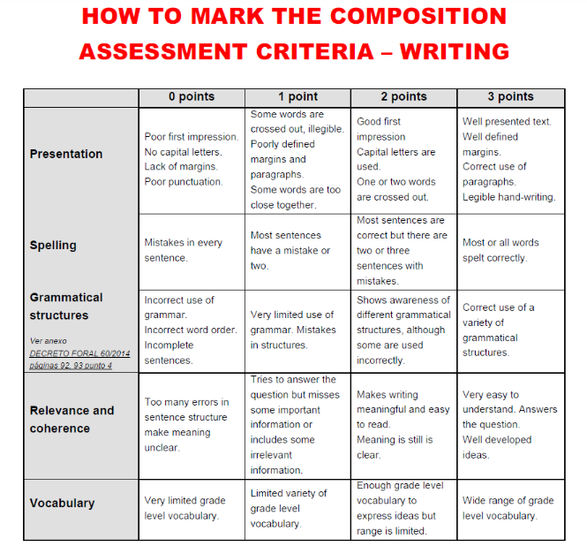

**Rubric – Speaking performance**

