# ESCUELA NORMAL DE EDUCACIÓN PREESCOLAR



**STUDENT’S NAME: Natalia Monserrat Alonso Moreno COURSE:** ENGLISH B1. OPENING NEW GLOBAL PERSPECTIVES

# LEARNING UNIT 1 EVIDENCE

**"Career Choices and Future Scenarios "**

# COMPETENCES OF THE GRADUATION PROFILE

Uses critical thinking and creativity to solve problems.

Uses language to establish harmonious and responsible relationships when exercising citizenship.

Reflects on one’s own learning process to act consciously in

communicative exchanges.

# SALTILLO, COAHUILA APRIL 22ND, 2024

**LEARNING UNIT 2 EVIDENCE**

## Career Choices and Future Scenarios

#### Objective:

* To practice using the first conditional structure in English.
* To discuss preferences and skills related to career choices and work using gerunds.
* To enhance speaking and listening skills through group discussions and presentations.

## Instructions

#### Preparation activities:

1. Start by **reviewing** the information we practiced in class about grammar structures for the first conditional (if + simple present tense, + future tense) and the use of gerunds to talk about preferences and skills related to career choices.
2. **Provide examples** of both structures in class and do the **speaking activities** in teams.
3. **Go** to <https://www.liveworksheets.com/w/en/english-second-language-esl/128414> and

**complete** the exercise to practice the first conditional.

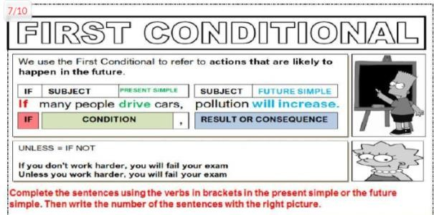

**PASTE A SCREENSHOT OF YOUR RESULT HERE.**

1. Paste a picture of three celebrities and write 4 sentences about their skills and preferences using gerunds. Check and follow the example.

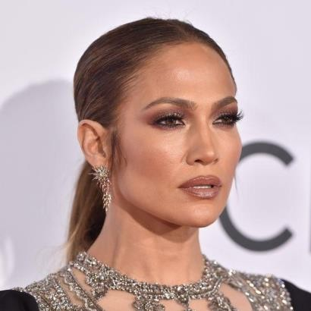

She loves ***going*** out with her friends.

She is interested in ***designing*** clothes and perfumes. She is good at ***doing*** business.

She is not good at ***cooking*** for her family.

### PASTE YOUR CELEBRITIES AND SENTENCES HERE.



1. Ni-ki loves dancing to all types of music, especially jazz.
2. Ni-ki hates waking up in the morning.
3. Ni-ki is good at painting and drawing things, he enjoys art.
4. Ni-ki is not good at cooking food, because he is too young
5. Leehan loves taking care of his fish.
6. Leehan loves producing music.
7. Leehan is good at staying silent, especially when he watches his fishbowl.
8. Leehan is not good at lying, he is very reliable.
9. ​



1. Terry loves doing magic tricks, it’s his hidden talent.
2. Terry is interested in learning a new language.
3. Terry is good at doing exercise, he is very strong.
4. Terry is not good at playing games with his friends, he is not patient.

#### Development:

1. Write a list of five **unusual or extraordinary professions**.
   1. Dancer
   2. Panda keeper
   3. Ice cream taster
   4. Hand model
   5. Human alarm
2. Do some research on **ONE** of the professions you wrote and write a list of **five adjectives** that this worker with a short description. Write **ten sentences** to talk about this worker´s skills and preferences using gerunds (-ing).

|  |  |  |
| --- | --- | --- |
| **JOB / PROFESSION** | **ADJECTIVES** | **SKILLS / PREFERENCES** |
| *Ex. Teacher* | *A teacher is* ***patient****, she has to*  *listen to a lot of children at the same time.* | *A teacher is good at* ***creating***  *material for students.* |
| **PANDA KEEPER** | 1. *A panda keeper is* ***strong****, pandas are playful and can knock him to the ground.* 2. *A panda keeper is* ***patient****. He spends 4 to 6 hours with the pandas.* 3. *A panda keeper is* ***responsible****, he is taking care a life* 4. *A panda keeper is* ***friendly,*** *he needs to be kind with the pandas.* 5. *A panda keeper is a* ***connoisseur****. Has great knowledge about behavior, diet and health* | 1. *A panda keeper is good at* ***organizing*** *the activities that are on his agenda to do.* 2. *A panda is good at being* ***punctual*** *at work. He always has to cook the pandas' food on time.* 3. *A panda keeper loves being very* ***energetic****, they are always* ***playing*** *with the playful pandas, they are so clingy that you can't leave them alone* 4. *A pandas keeper loves* ***observing and identifying*** *any changes in behavior or health.* 5. *A panda keeper is good at*   ***giving*** *special care to the panda.*   1. *A panda keeper is good for*   ***calming*** *pandas.*   1. *A panda keeper is good at* ***solving*** *problems. Pandas are always exposed to unexpected challenges* 2. *A panda keeper is good at*   ***working*** *as a team. They always* |

|  |  |  |
| --- | --- | --- |
|  |  | *work with veterinarians to take good care of the pandas.*   1. *A panda keeper is good at* ***training****. Pandas require useful behaviors for their survival* 2. *A panda keeper is good at*   ***giving*** *affection. Pandas need*  *constant attention and love* |

1. Create **TEN** scenarios for the profession you chose, imagine you practice this profession and write sentences using the **FIRST CONDITIONAL**. Remember the structure: CONDITIONAL (If + simple present) + CONSEQUENCE (future). Check and follow the example.

Ex. ***If a kid falls*** *down in recess, I* ***will take*** *him to the medical office.*

1. If a panda feels sick, you’ll have to call a veterinarian.
2. If you don't prepare food on time, you will have many hungry pandas.
3. If a panda falls, the keeper will check it.
4. If a panda feels bored, you will play with it.
5. if you prepare the pandas' food, you will check that everything is in good condition
6. If you clean the pandas habitat, you’ll need to make sure the pandas are safe
7. If you receive visits for the pandas, you will remember the rules to the visitors.
8. You will have to bathe the pandas if it gets dirty.
9. If the panda is rejected by its mother, you will be its new mother.
10. If you are careless, the panda will imitate everything you do.

#### Presentation:

1. Choose one person from the team to talk about the profession to the rest of the class, the presentation must include.

* Picture of the profession
* Introduction of the team
* List of professions or jobs
* The chosen profession and the adjectives, skills and preferences
* Scenarios using conditionals

**NOTE:** THE GRADE FOR SPEAKING PERFORMACE WILL BE THE SAME FOR ALL THE MEMBERS OF THE TEAM.

### REFLECTIVE NOTE

a. Reflect on what you learned from the activity and write a reflective note about the learning outcomes from this project. Write about what you are able to do and what you have to practice more.

#### Write your reflective note here.

**Con la construcción de esta evidencia fue posible reflexionar sobre como el inglés es un vehículo para promover la inclusión y la equidad en la educación, uno de tantos aspectos que tendrá relevancia en nuestro labor docente para actuar de manera ética ante diversidad de situaciones, por medio de este proyecto fue posible proyectar los aspectos que hemos estado aprendiendo en tanto “first conditional and preferences/skills” considero que aún me hace falta práctica para identificar cuándo y cómo utilizar los gerundios, y la manera correcta de emplear los verbos en sus diferentes tiempos, sin embargo, considero que es posible conseguirlo a través de la práctica y confianza por este idioma.**

**EVALUATION CHECKLIST**

|  |  |  |  |  |  |
| --- | --- | --- | --- | --- | --- |
| 1. **– Poor** 2. **– Fair** 3. **– Good** 4. **– Very good** 5. **– Excellent** | **1** | **2** | **3** | **4** | **5** |
| **PREPARATION ACTIVITIES (INDIVIDUAL)** | | | | | |
| The student participated actively in the speaking activities in class. |  |  |  |  |  |
| The product includes a screenshot of the online worksheet to review the  first conditional. |  |  |  |  |  |
| The product includes 3 pictures of celebrities with 4 sentences each  about their preferences and skills using gerunds. |  |  |  |  |  |
| **DEVELOPMENT ACTIVITIES (GROUP)** | | | | | |
| The product includes a list of 5 unusual or extraordinary jobs or  professions. |  |  |  |  |  |
| The product includes 5 sentences using adjectives to describe a worker  for the chosen profession. |  |  |  |  |  |
| The product includes 10 sentences using gerunds to talk about the skills  and preferences of the chosen profession. |  |  |  |  |  |
| The product includes 10 scenarios using the first conditional. |  |  |  |  |  |
| The vocabulary from both cycles are included in the project  development. |  |  |  |  |  |
| The first conditional is used accurately. |  |  |  |  |  |
| The gerund is used accurately to talk about skills and preferences in a job  or career. |  |  |  |  |  |
| **PRESENTATION (GROUP)** | | | | | |
| The presentation covers all the required elements |  |  |  |  |  |
| Grammar and vocabulary |  |  |  |  |  |
| Fluency |  |  |  |  |  |
| Pronunciation |  |  |  |  |  |
| Rhythm and intonation |  |  |  |  |  |
| **REFLECTIVE NOTE** | | | | | |
| The product includes a reflective note where the student shares what she  learnt and what she has to practice more. |  |  |  |  |  |
| **TOTAL** | **79/80** | | | | |