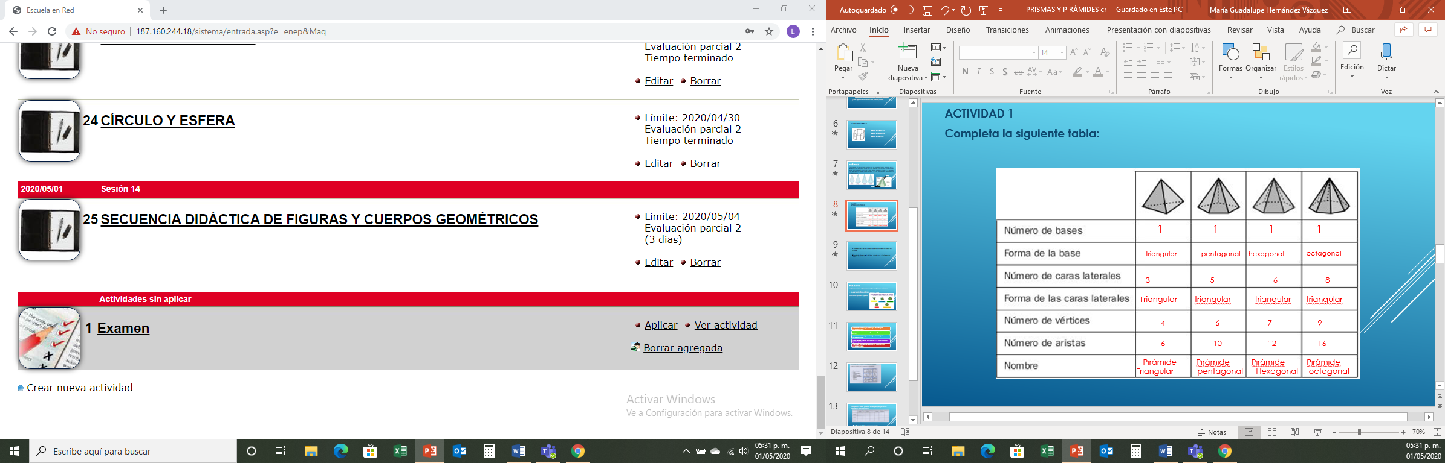

|  |  |  |  |  |  |  |  |
| --- | --- | --- | --- | --- | --- | --- | --- |
|  | Prisma triangular | Cubo | Prisma pentagonal | Tetraedro | Piramide cuadrada | Piramide pentagonal | Octaedro |
| Vertice | 6 | 8 | 10 | 4 | 5 | 6 | 6 |
| Aristas | 9 | 12 | 15 | 6 | 8 | 10 | 12 |
| Caras | 5 | 6 | 7 | 4 | 5 | 6 | 8 |

