**ESCUELA NORMAL DE EDUCACIÓN PREESCOLAR**

**ENGLISH A1.2 DEVELOPING ELEMENTARY CONVERSATIONS**

**UNIT 10 – SPORTS VOCABULARY**

**DEAR STUDENTS,**

**DURING THIS UNIT YOU WILL LEARN VOCABULARY RELATED TO SPORTS, TALENTS AND ABILITIES AND YOU WILL BE ABLE TO TALK ABOUT THEM.**

**ACTIVITY 1 “TALENTS AND ABILITIES”**

Look the unknown words up in a **dictionary** and **classify** them in the chart.

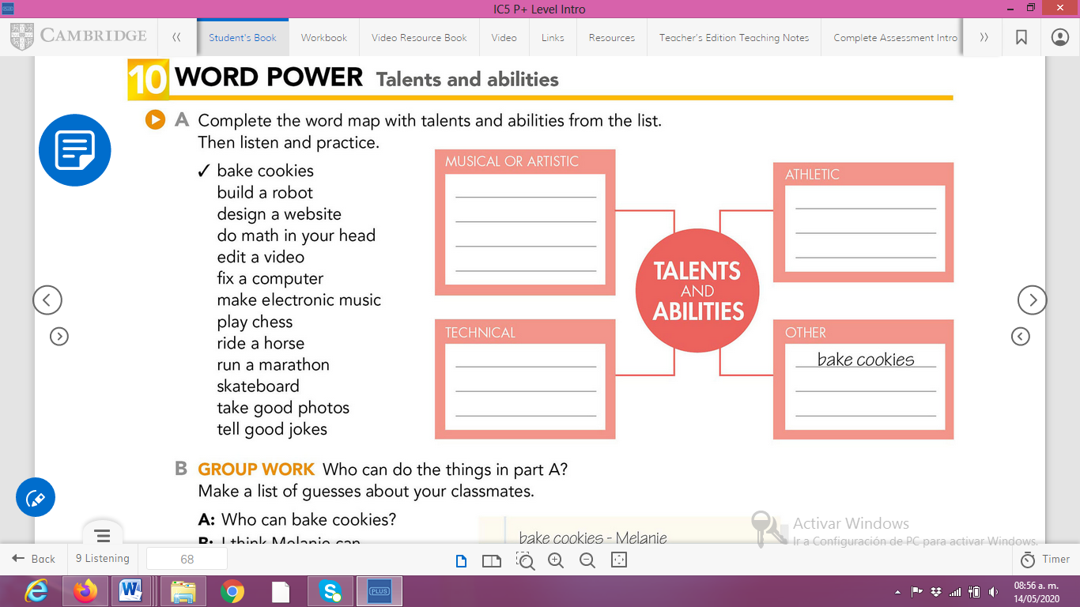

**ACTIVITY 2 “TALENTS AND ABILITIES”**

Write the name of a **person you know** or of a **famous person** who has each talent or ability.

|  |  |  |  |
| --- | --- | --- | --- |
| TALENTS AND ABILITIES | | | |
| **Act** | Brad Pitt | **Run a marathon** |  |
| **Bake a cake** |  | **Sing** |  |
| **Build a robot** |  | **Sing English songs** |  |
| **Design a website** |  | **Skate** |  |
| **Do yoga** |  | **Skateboard** |  |
| **Draw** |  | **Snowboard** |  |
| **Edit a video** |  | **Take photos** |  |
| **Fix a car** |  | **Tell good jokes** |  |
| **Fix a computer** |  | **Upload photos** |  |
| **Ice-skate** |  | **Use a computer** |  |
| **Paint** |  | **Write poems** |  |
| **Play a sport** |  | **Ride a horse** |  |

**ACTIVITY 3 “MUSICAL INSTRUMENTS”**

**Paste a picture** of each musical instrument. You can use a dictionary in case you don’t know the meaning of a word.

|  |  |  |  |
| --- | --- | --- | --- |
| **MUSICAL INSTRUMENTS** | | | |
| **Bass** |  | **Saxophone** |  |
| **Drums** |  | **Trumpet** |  |
| **Guitar** |  | **Violin** |  |
| **Piano** |  | **Accordion** | Weltmeister FB 26 Freebass Accordion – Thomann Elláda |

**ACTIVITY 4 “SPORTS”**

Find the sports contained in the box in the following letter soup.

**SPORTS**

|  |  |  |  |  |  |  |  |  |  |  |  |  |  |  |
| --- | --- | --- | --- | --- | --- | --- | --- | --- | --- | --- | --- | --- | --- | --- |
| R | S | R | J | Q | S | K | F | G | L | B | V | G | G | Q |
| L | J | T | W | O | S | O | T | L | I | H | S | N | J | P |
| W | U | S | C | V | O | J | A | V | A | N | Y | I | E | C |
| J | R | C | A | T | X | B | G | Q | O | R | Y | T | M | B |
| Q | E | Q | B | X | Y | C | V | W | G | E | V | A | R | K |
| R | U | A | T | E | N | L | B | H | K | E | O | K | I | K |
| Q | L | D | L | T | T | O | L | C | T | U | J | S | O | G |
| L | G | L | S | G | A | E | O | A | X | L | U | E | M | N |
| C | O | M | E | R | H | H | N | C | B | J | Q | C | Y | I |
| V | J | E | D | T | I | I | C | N | J | E | D | I | I | M |
| A | D | I | G | O | K | H | N | N | I | S | S | C | Q | M |
| X | N | O | R | I | I | E | E | S | U | S | C | A | M | I |
| G | L | O | J | O | N | B | L | X | J | L | Z | P | B | W |
| F | R | T | T | K | G | B | K | N | W | K | C | N | F | S |
| W | R | Z | I | A | U | C | R | H | M | Y | S | R | Y | X |

|  |  |  |
| --- | --- | --- |
| BASEBALL | FOOTBALL | GOLF |
| HIKING | HOCKEY | ICESKATING |
| SNOWBOARDING | SOCCER | SWIMMING |
| TENNIS | VOLLEYBAL |  |

**ACTIVITY 5**

Make sentences to talk about the sports you **like** or the ones you **don’t like**.

1. I *like* baseball.
2. I *don’t like* golf.