**ESCUELA NORMAL DE EDUCACIÓN PREESCOLAR**

**ENGLISH A1.2 DEVELOPING ELEMENTARY CONVERSATIONS**

**UNIT 10 – What sports do you like?**

**Dear students, in the following activities you will learn how to use CAN or CAN’T to talk about your talents and abilities.**

**ACTIVITY 1**

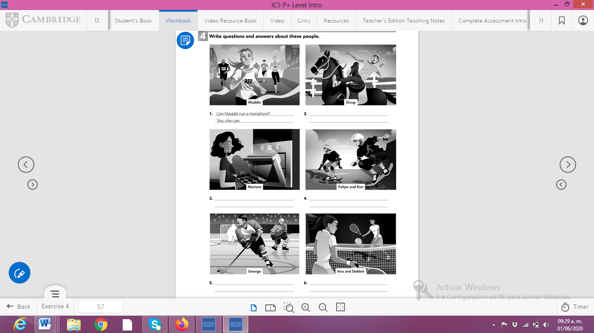

**ACTIVITY 2**

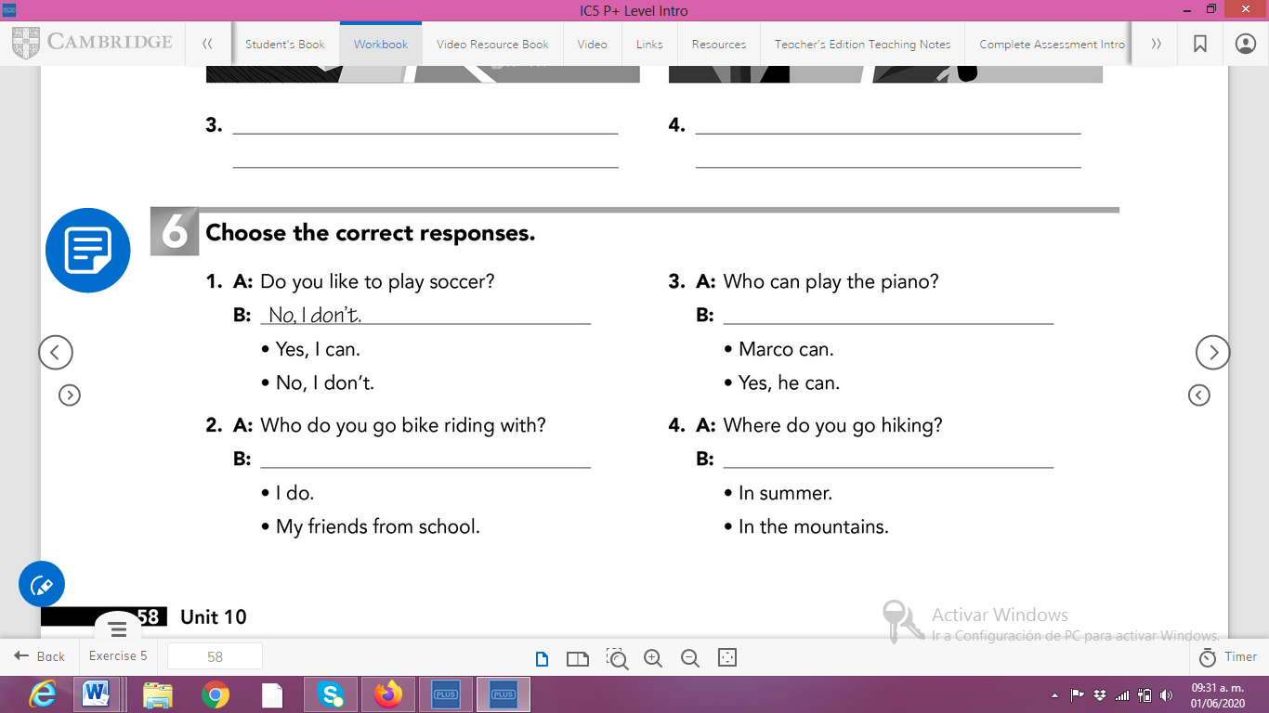

**ACTIVITY 3**

Write each sentence in a different way. Use the sentences in the box.

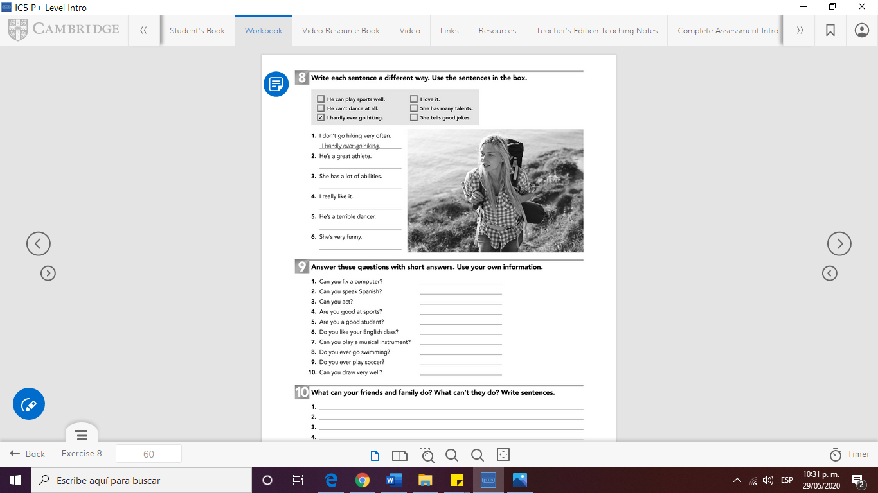

**ACTIVITY 4**

Answer these questions using short answers. Use your own information

1. Can you speak English? _________________
2. Can you rap?
3. Are you good at sports?
4. Are you a good student?
5. Do you like your English class?
6. Can you play a musical instrument?
7. Do you ever go bike riding?
8. Can you draw well?
9. Can you act?



**ACTIVITY 5**

What can your friends or family do? Write 5 sentences.

*Example: My father can play the guitar.*