**UNIT 1**

**WHERE ARE YOU FROM?**

**OBJECTIVE :** To scan and read for details in an article about names

Before you read, check the following vocabulary you will find in the text

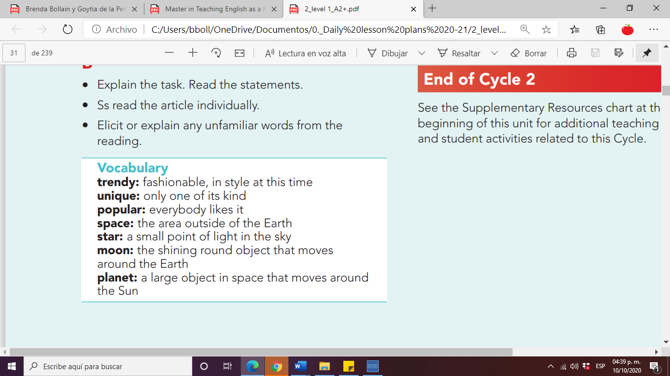

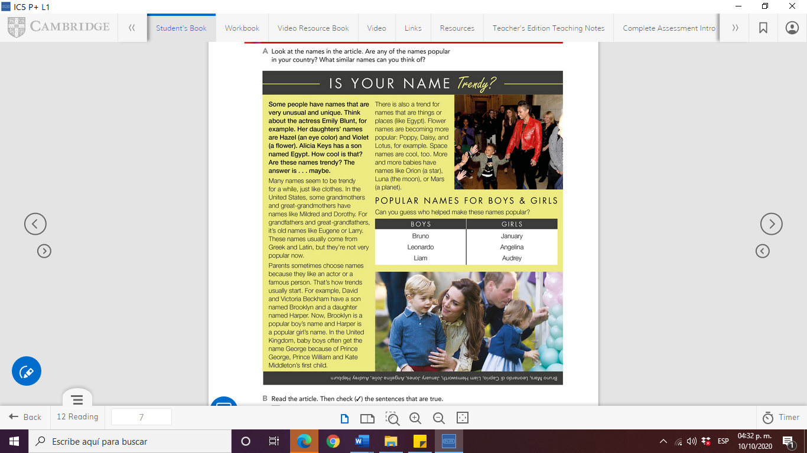

**ANSWER THE QUESTIONS ABOUT THE ARTICLE IN THIS FORM**

<https://forms.office.com/Pages/ResponsePage.aspx?id=S-T_USk6R0SMOxg3uJ4GFKbXckc2RLdJgySdBxTdgnNUOEQ0VjFGSUxPT09IT09FVTA2R0RINkc1Wi4u>

**prepare a short presentation about the meaning and origin of your name.**

**You will present on Friday. October 16th in our ZOOM session.**

**Example:**

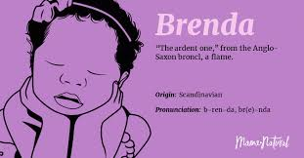

**My name’s origin is Aglo-Saxon**

**It means “the burning one”. My mom had a dream when she was pregnant and, in her dream, she heard the name Brenda. She knew I was a baby girl before I was born.**

**Brendas are natural leaders who follow their instinct. They are trustful and warmhearted.**