**ESCUELA NORMAL DE EDUCACIÓN PREESCOLAR**

**ENGLISH B1.2**

**UNIT 3 “LEND A HAND”**

**VOCABULARY**

Complete the chart writing a situation in which you do each of these actions and an expression you would use for each one.

|  |  |  |
| --- | --- | --- |
| **Collocation** | **Situation** | **What you usually say** |
| Accept a gift |  |  |
| Accept a request |  |  |
| Accept an apology |  |  |
| Accept an invitation |  |  |
| Ask for a favor |  |  |
| Decline a request |  |  |
| Do a favor |  |  |
| Give a compliment |  |  |
| Give a gift |  |  |
| Make a phone call |  |  |
| Make a request |  |  |
| Offer an apology |  |  |
| Receive a compliment |  |  |
| Receive a gift |  |  |
| Receive an invitation |  |  |
| Return a favor |  |  |
| Return a compliment |  |  |
| Turn down an invitation |  |  |

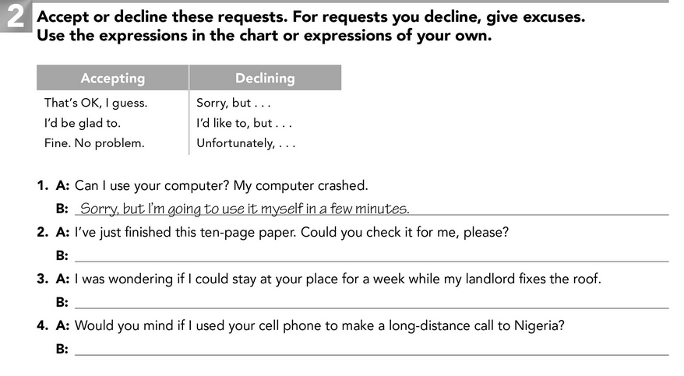

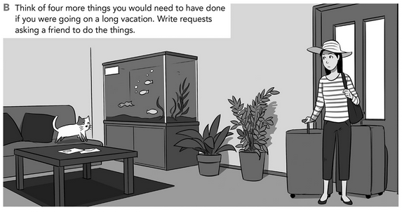

1. *Could you water the plants?*