**ESCUELA NORMAL DE EDUCACIÓN PREESCOLAR**

**ENGLISH B1.2**

**BOOK UNIT 5 – EXPANDING YOUR HORIZONS**

**GRAMMAR**

Dear students, during the week we will discuss living in a foreign country and describing cultural expectations and differences.

**ACTIVITY 1 – READING ABOUT TRAVELING ABROAD – 10 PTS.**

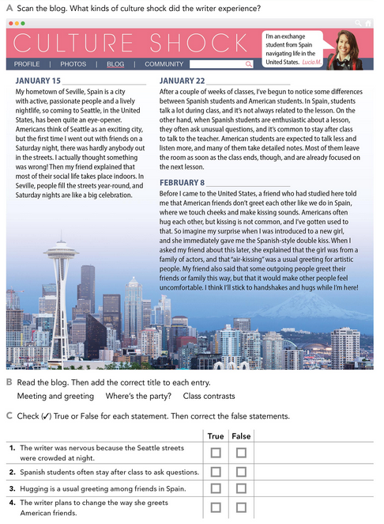

**ACTIVITY 2 – NOUN PHRASES CONTAINING RELATIVE CLAUSES – 45 PTS.**

Read the following information and analyze the examples. These are expressions to discuss living in a foreign country.

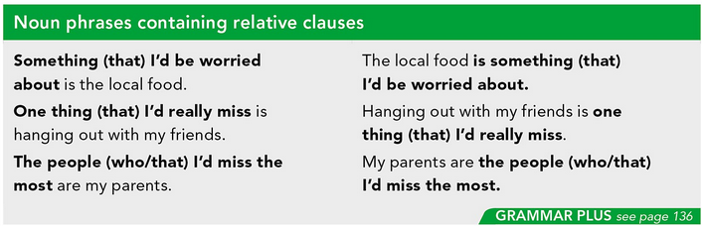

Complete the sentences about living in a foreign country using the phrases in the box. Look at the examples.

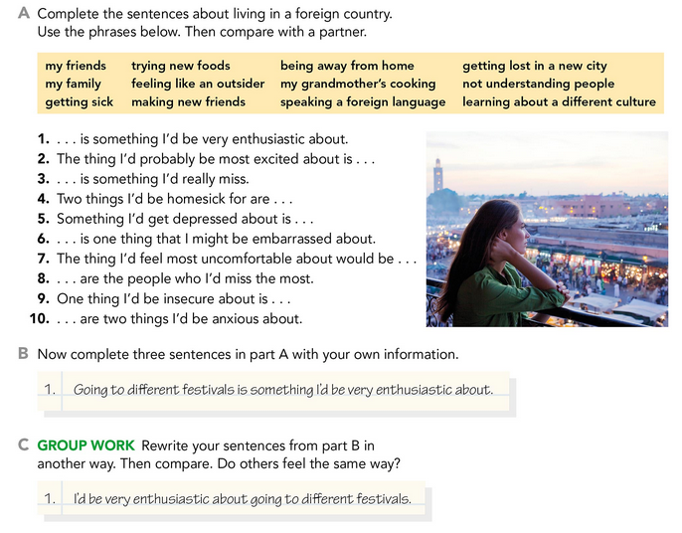

Write your responses here:

Write about living in a foreign country. In the first paragraph, write about two things you would enjoy. In the second paragraph, write about two things you might worry about. Look at the example.

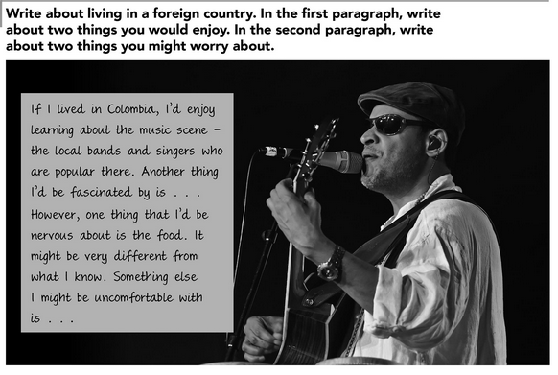

**ACTIVITY 3 – EXPECTATIONS – 45 PTS.**

Read the following information and analyze the examples. These are expressions to describe cultural differences and customs.

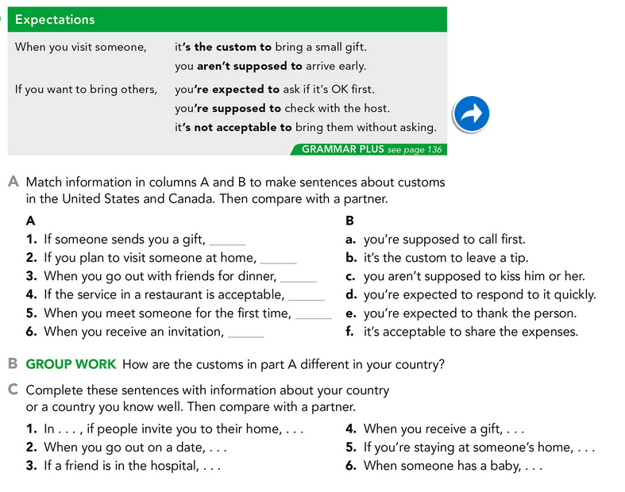

Write your responses here:

Complete these sentences by giving information about customs in a country you know.

