**LEARNING UNIT 3 PROJECT**

**“WRITE A STORY”**

Aim of the project:

To give students practice using the simple past to tell stories and make questions.

**PREPARATION ACTIVITIES**

**Activity 1.** Classify the verbs by regular and irregular, then write the past tense. Look at the example.

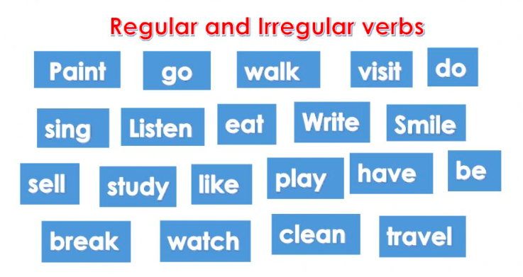

|  |  |  |  |
| --- | --- | --- | --- |
| **REGULAR VERBS (-ED)** | | **IRREGULAR VERBS** | |
| **BASE FORM OF THE VERB** | **VERB IN PAST** | **BASE FORM OF THE VERB** | **VERB IN PAST** |
| *watch* | *watched* | *break* | *broke* |
|  |  |  |  |
|  |  |  |  |
|  |  |  |  |
|  |  |  |  |
|  |  |  |  |
|  |  |  |  |

**Activity 2**. Unscramble the words to write a question in the simple past. Look at the example.

*Example*:

* go? / they / did / Where
* *Where did they go?*

1. she / What / see? / did
2. like / museum? / Did / the / you
3. study? / Where / did / Henry
4. did / family / hear? / What / your
5. the / concert? / you / like / did
6. you / play? / did / Where
7. What / did / Alexandra / like?
8. did / Where / go? / teacher / the
9. they / What / did / learn?
10. Did / see / cows? / you

**DEVELOPMENT ACTIVITIES**

**Activity 3.** Write the name of 5 tales for children.



**Activity 4.** Choose a story for children: _________________________________________

**Activity 5.** Paste pictures and write affirmative and/or negative statements in the past tense to tell a story for children. *Look at the example.*

|  |  |
| --- | --- |
| **PICTURE** | **STATEMENTS** |
|  | * Three little pigs **lived** in a small house with their mom. * Their mom **said** “Build your own house!” |
|  | * One pig **built** a house with straw. |
|  | * The second pig **built** a house with wood. |
|  | * The third pig **built** a house with bricks. |
|  | * One day, a big bad wolf **came**. * He **knocked** on the door of the first pig. * The pig **didn’t open**. * The wolf **blew** the house down. * The pig **ran** to his brother’s house. |
|  | * The big bad wolf **knocked** on the door of the second pig. * The pigs **didn’t open**. * The wolf **blew** the house down. * The pigs **ran** to their brother’s house. |
|  | * The big bad wolf **knocked** on the door of the third pig. * The pigs **didn’t open**. * The wolf **blew** but the house didn’t fall. |
|  | * The wolf **climbed** and **entered** through the chimney. * He **fell** in a bowl of hot soup. * He **ran** away and never **came** back. |

**Activity 6.** Write ten questions that you could ask children about the story you wrote, then write the answers. Use yes/no questions and information questions in the simple past tense.

Example:

***Did the wolf eat the pigs?*** *No, he didn’t.*

***Where did the wolf fall?*** *He fell in a bowl of hot soup.*



**RUBRIC**

|  |  |  |  |  |
| --- | --- | --- | --- | --- |
| **Descriptor** | **PERFORMANCE LEVEL** | | | |
| **POOR**  **2 pts** | **AVERAGE**  **3 pts** | **GOOD**  **4 pts** | **EXCELLENT**  **5 pts** |

|  |  |  |  |  |
| --- | --- | --- | --- | --- |
| **Preparation activities** | The preparation activities are incomplete or they have a lot of mistakes (more than 8). | The preparation activities are complete and with no mistakes (5-8). | The preparation activities are complete with only a few mistakes (1-4). | The preparation activities are complete and with no mistakes. |
| **Development activities** | The story doesn’t include pictures and/or the story is difficult to understand due to missing sections.  The questions about the story are missing. | The story includes pictures and statements in the simple past to tell the story, but the story is incomplete and/or lack of coherence.  Some questions (yes/no and Wh-) or answers about the story are missing. | The story includes pictures and statements in the simple past to tell the story in a complete and coherent way.  Some questions (yes/no and Wh-) or answers about the story are missing. | The story includes pictures and statements in the simple past to tell the story in a complete and coherent way.  Questions (yes/no and Wh-) and answers about the story are included. |
| **Grammar and vocabulary** | Limited and incorrect use of regular and irregular verbs in past.  Few affirmative and negative statements are included in the story, and/or they are not structured correctly.  Questions and/or answers have a lot of grammar mistakes.  Google translate was used excessively. | Regular and irregular verbs in past were used with some grammar mistakes.  Affirmative and negative statements are included in the story, and they are structured with some mistakes that could affect understanding.  Ten questions with complete answers were written, and they are structured with some mistakes that could affect understanding.  Google translate was not used excessively. | Regular and irregular verbs in past were used in a correct manner.  Affirmative and negative statements are included in the story, and they are structured with only a few mistakes that doesn’t affect understanding.  Ten questions with complete answers were written, and they are structured with a few mistakes that doesn’t affect understanding.  Google translate was not used excessively. | Regular and irregular verbs in past were used in a correct manner.  Affirmative and negative statements are included in the story, and they are structured correctly.  Ten questions with complete answers were written, and they are structured correctly.  Google translate was not used. |
|  |  |  |  |  |
| **TOTAL** | | | | **/15** |